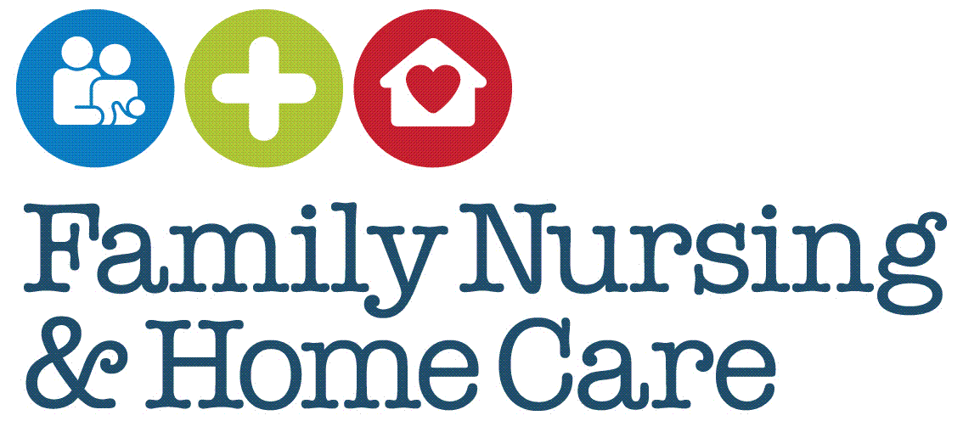

**Complaint Handling Policy**

**May 2025**

**Document Profile**

|  |  |  |
| --- | --- | --- |
| **Type** | Policy | |
| **Title** | Complaint Handling | |
| **Author** | Claire White | |
| **Category**  Clinical / Corporate / Education / Health & Safety / Human Resources / Information Governance | | Corporate |
| **Date approved by Organisational Governance Approval Group** | | 7.05.25 |
| **Date approved by Chief Executive Officer** | | 27.05.25 |
| **Review date** | 5 years from approval (or before if required) | |
| **Document Status** | This is a controlled document. Whilst this document may be printed, the electronic version posted on the intranet is the controlled copy. Any printed copies of this document are not controlled. As a controlled document, this document should not be saved onto local or network drives but should always be accessed from the intranet. | |

**Version Control/Changes Made**

|  |  |  |  |
| --- | --- | --- | --- |
| **Date** | **Version** | **Summary of changes** | **Author** |
| November 2020 | 1 | Complaints policy rewritten to reflect current complaints management |  |
| March 2025 | 2 | * Rewrite of complaints policy based upon NHS/Parliamentary & Health Ombudsman Complaints Standards 2022 The main changes include: * No longer use the term formal and informal * The capture of low-level complaints that have been resolved on the spot * The use of an early resolution form where complaints can be resolved with 5 days * Updated investigation template in appendix * Updated consent forms in appendix * Updated complaint leaflets in appendix |  |
|  |  |  |  |

**CONTENTS**

1 INTRODUCTION 1

1.1 Rationale 1

1.2 Scope 2

1.3 Role and Responsibilities 3

2 POLICY 4

2.1 Policy Aims 4

2.2 Principles 4

2.3 Complaint information 4

3 PROCEDURE 5

3.1 Identifying a complaint 6

3.2 Who can make a complaint? 7

3.3 Consent 7

3.4 Timescale for making a complaint 8

3.5 Complaints and other procedures 8

3.6 Confidentiality of complaints 9

3.7 Making sure people know how to complain and where to get support 9

3.8 Process when a complaint is received 10

3.9 Complaints that can be resolved quickly 10

3.10 Acknowledging complaints 11

3.11 Focus on early resolution 11

3.12 Resolved complaints 11

3.13 Unresolved complaint 11

3.14 A closer look into the issues (investigation) 11

3.15 Clarifying the complaint and explaining the process 12

3.16 Carrying out the investigation 12

3.17 Providing a remedy 13

3.18 The final written response 13

3.19 Support for staff 14

3.20 If the person is not happy with the response 14

3.21 Complaints involving multiple organisations 15

3.22 Monitoring, demonstrating learning and data recording 15

4 MONITORING COMPLIANCE 15

5 CONSULTATION PROCESS 17

6 EQUALITY IMPACT STATEMENT 17

6.1 EQUALITY IMPACT SCREENING TOOL 19

7 IMPLEMENTATION PLAN 20

8 GLOSSARY OF TERMS 20

9 REFERENCES 21

10 APPENDICES 22

10.1 Appendix 1 Patient/Client Consent Form 22

10.2 Appendix 2 Consent for representative to act 22

10.3 Appendix 3 Consent where a person lacks capacity or has died 22

10.4 Appendix 4 Consent to share information with other organisations 22

10.5 Appendix 5 Easy Read Consent (adaptable form) 22

10.6 Appendix 6 Complaint Resolution Form 22

10.7 Appendix 7 Complaint Investigation Template 22

10.8 Appendix 8 Complaints Leaflet 23

10.9 Appendix 9 Complaints leaflet (Child) 23

10.10 Appendix 10 Complaints Leaflet Easy Read 23

10.11 Appendix 11 Verbal Feedback Form 23

# INTRODUCTION

## Rationale

Complaints offer a valuable source of learning to help improve services for everyone. Good complaint handling builds a direct and positive connection between those who provide services and the people who use them.

[The NHS Complaint Standards](https://www.ombudsman.org.uk/organisations-we-investigate/complaint-standards/nhs-complaint-standards) were developed in partnership by the Parliamentary and Health Service Ombudsman and published in December 2022. The Standards are based upon [My Expectations](https://www.ombudsman.org.uk/publications/my-expectations-raising-concerns-and-complaints), which sets out what patients want to happen when they make a complaint about health or social care services.

The Standards are based upon four core pillars:

* welcoming complaints in a positive way and recognising them as valuable insight for

organisations

* supporting a thorough and fair approach that accurately reflects the experiences of everyone involved
* encouraging fair and accountable responses that provide open and honest answers as soon as possible
* promoting a learning culture by supporting organisations to see complaints as opportunities to improve services.

The NHS Complaint Standards have been used as best practice to direct Family Nursing & Home Care’s (FNHC) approach to complaint handling which will be outlined within this policy and procedures. The NHS Complaint Standards:

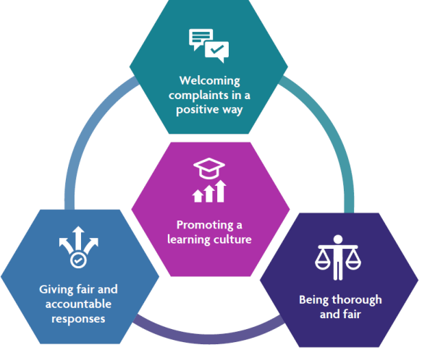

(Figure 1 NHS, 2022, p.12)

## Scope

This policy and procedure applies to all activities carried out by FNHC and is relevant to all staff. In addition to clinical/client facing services, the same processes and principles will apply to complaints regarding non-clinical departments and services within FNHC. The Standards and this policy support FNHC’s mission, vision and values:

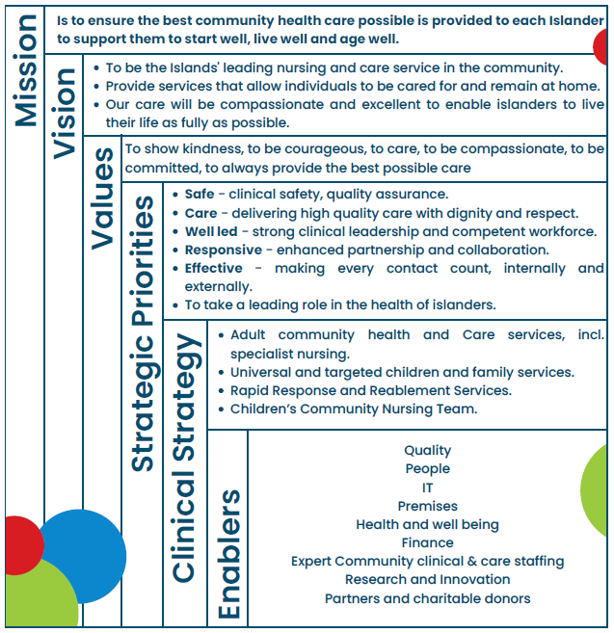

Issues which cannot be dealt with under this procedure are:

* a complaint made by an employee of FNHC about any matter relating to their employment.
* a complaint which has previously been investigated under these or previous procedures.

## Role and Responsibilities

**Governance & Clinical Sub-Committee members**

Are responsible for reviewing complaints on a quarterly basis to ensure that themes are identified and that appropriate learning identified and actioned. Members will form part of an Advisory Panel where required.

**Chief Executive Officer (CEO)**

The CEO has overall responsibility for ensuring that there are systems and resources in place to support the requirements of this policy and that the policy and procedures meets the requirements set out by the Jersey Care Commission and any other relevant, contractual, legislative or regulatory requirement.

**Director of Governance & Care**

The Director of Governance & Care has overall responsibility for the management of complaints which includes: ensuring that there is an evidenced based policy and procedures that is implemented effectively across the organisation; recording and monitoring complaints; providing the final written response to the complaint (unless delegated). They should be satisfied that the investigation has been carried out in accordance with this procedure and guidance, and that the response addresses all aspects of the complaint. They review the information gathered from complaints regularly (at least quarterly) and use this to consider how services could be improved, or how internal policies and procedures could be updated. They report on the outcomes of these reviews via the organisation’s governance structure. They are also responsible for making sure complaints are central to the overall governance of the organisation.

**Head of Quality & Safety**

Will act with delegated authority on behalf of the Director of Governance & Care where required and will ensure that annual audit is scheduled and completed.

**Registered Managers, Operational Leads, Heads of Departments**

Are responsible for:

* overseeing complaints and the way we learn from them
* overseeing the implementation of actions required because of a complaint, to prevent failings happening again
* completing and contributing to complaint investigations
* preparing and quality assuring the written response
* making sure staff are supported both when handling complaints and when they are the subject of a complaint

**All Staff**

All staff are expected to proactively respond to service users and their representatives and to support them to deal with any complaints raised at the ‘first point of contact’. Staff who have contact with patients, service users, or those that support them, are also expected to deal with complaints in a sensitive and empathetic way. This includes making sure people are aware of sources of support and advice. In addition, staff are responsible for listening and providing an answer to the issues quickly and capturing and acting on any learning identified.

# POLICY

## Policy Aims

The policy aims to ensure that:

* all complaints are well managed as quickly as possible and in accordance with best practice standards
* patients, clients, their families and carers and anyone else affected by the actions of FNHC feel listened to
* staff are empowered to deal with complaints as they arise in an open and non-defensive way
* the learning from complaints is identified and used for service development and improvement
* the complaints service is accessible, well publicised, open and transparent
* the complaints procedure is supportive for those who find it difficult to complain

## Principles

Complaint handling will be based upon the following principles:

* all complaints are well managed as quickly as possible and in a sensitive manner
* staff are empowered to deal with complaints as they arise in an open and non-defensive way
* responses are open and transparent
* FNHC seeks continuous improvement arising from feedback
* complainants are kept informed of the progress and outcome of the investigation
* staff involved in complaints are given support
* action to rectify the cause of complaint is identified, implemented and evaluated
* meaningful apologies are offered as appropriate

## Complaint information

Anyone who uses FNHC services or is affected by these services should know how to speak up if something is not right. Information is available on the FNHC Website, leaflets for adults (Appendix 8) and children (Appendix 9) and Easy Read (Appendix 10) are available to give to patients and clients and information about how to raise a concern or issue is displayed in clinic settings.

# PROCEDURE

Alongside this policy are separate Standard Operating Procedures for the handling of Feedback and Complaints which set out the key processes for staff dealing with feedback and complaints on a day to day basis. The following procedures provide further information and clarification for those involved in investigation of complaints.

The flow chart below provides an outline of the complaints handling process.

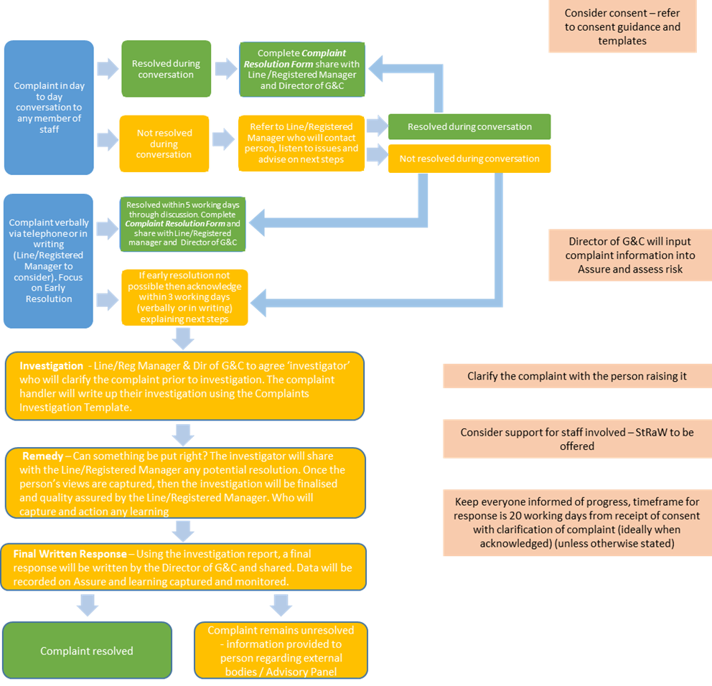

## Identifying a complaint

**Everyday conversations with people who use FNHC services**

Staff speak to people who use FNHC services every day. This can often raise issues, requests for a service, questions or worries that staff can help with immediately. FNHC encourage people to discuss any issues they have with staff, as they may be able to sort the issue out to their satisfaction quickly and without the need for them to make a complaint.

**When people want to make a complaint**

FNHC recognises that it cannot always resolve issues as they arise and that sometimes people will want to make a complaint.

**Feedback and complaints**

People may want to provide feedback instead of making a complaint. People can provide feedback, make a complaint, or do both. Feedback can be an expression of dissatisfaction (as well as positive feedback) but is normally given without wanting to receive a response or make a complaint.

People do not have to use the term ‘complaint’. Use the language chosen by the patient, service user, or their representative, when they describe the issues they raise (for example, ‘issue’, ‘concern’, ‘complaint’, ‘tell you about’). Always speak to people to understand the issues they raise and how they would like them considered.

If it is considered that a complaint (or any part of it) does not fall under this procedure explain the reasons for this. Do this in writing where necessary to the person raising the complaint and provide any relevant explanation and signposting information.

Complaints can be made:

* in person
* by telephone: 01534 497600
* in writing: to Director of Governance & Care, Family Nursing & Home Care, Le Bas Centre, St Saviour, JE2 4RP.
* by email: [feedback@fnhc.org.je](mailto:feedback@fnhc.org.je)

Consider all accessibility and reasonable adjustment requirements of people who wish to make a complaint in an alternative way. Record any reasonable adjustments made.

Acknowledge a complaint within three working days of receiving it. This can be done in writing, electronically or verbally.

Where an anonymous or general complaint that would not meet the criteria for who can complain (see below) is received, take a closer look into the matter to identify if there is any learning for the organisation (unless there is a reason not to).

## Who can make a complaint?

Any person may make a complaint to FNHC if they have received or are receiving care and services from the organisation. A person may also complain if they are not in direct receipt of FNHC care or services but are affected, or likely to be affected by any action, inaction or decision made by FNHC.

If the person affected does not wish to deal with the complaint themselves, they can appoint a representative to raise the complaint on their behalf. There is no restriction on who may represent the person affected. However, they will need to give their consent for their representative to raise and discuss their complaint and to see their personal information (including any relevant health care records).

If the person affected has died, is a child or is otherwise unable to complain because of physical or mental incapacity, a representative may make the complaint on their behalf. There is no restriction on who may act as representative but there may be restrictions on the type of information FNHC may be able to share with them.

If a complaint is brought on behalf of a child be satisfied that there are reasonable grounds for a representative bringing the complaint rather than the child. If not satisfied share the reasons with the representative in writing.

If at any time it is identified that a representative is not acting in the best interests of the person affected, assess whether it is necessary to stop consideration of the complaint. If this course of action is taken, share the reasons with the representative in writing. In such circumstances advise the representative that they may complain to the Jersey Care Commission if they are unhappy with this decision.

## Consent

|  |  |
| --- | --- |
| Patient/client/child consent form (Appendix 1) | Where the complaint comes directly from the patient/client/child and the process has been explained there is no need to complete a form unless information needs to be shared or gathered from external agencies/organisations |
| Consent for a representative to act (Appendix 2) (consider Gillick Competence and Fraser Guidelines where necessary) | Where a patient / client / child is able to provide consent for someone to act on their behalf |
| Consent where the patient/client/child lacks capacity or has died (Appendix 3) | Where the patient does not have capacity or has died this clarifies under what authority the person has. |
| Consent to share/gather information from other organisations (Appendix 4) | Where other organisations may hold information / FNHC will share information in order for a complaint to be investigated |
| Easy read consent form (Appendix 5) | This can be adapted depending on the consent required |

## Timescale for making a complaint

Complaints must be made to Family Nursing & Home Care within 12 months of the date the incident being complained about happened or the date the person raising the complaint found out about it, whichever is the later date.

If a complaint is made after that 12 month deadline, consider it if:

* there were good reasons for not making the complaint before the deadline, and
* it is still possible to properly consider the complaint

If there is not a good reason for the delay or it is not possible to properly consider the complaint (or any part of it), the person will be informed in writing. Also explaining that, if they are dissatisfied with that decision, they can complain to the appropriate external body (where relevant) which may include the Jersey Care Commission, Jersey Charities Commission, Jersey Financial Commission, Jersey Office of the Information Commissioner or Health & Community Services Commissioning.

## Complaints and other procedures

Staff who deal with complaints should be supported by their line manager and be able to identify when it may not be possible to achieve an outcome through the complaint process on its own. When this happens, the staff member dealing with the complaint will inform the person making the complaint and give them information about any other process that may help address the issues which may have the potential to provide the outcomes sought.

This can happen at any stage in the complaint handling process and may include identifying issues that could or should:

* trigger a patient safety investigation
* trigger safeguarding procedures
* involve a coroner investigation or inquest
* trigger a relevant regulatory process, such as fitness to practice investigations or referrals
* involve a relevant legal issue that requires specialist advice or guidance.

When another process may be better suited to cover other potential outcomes, staff should seek advice and provide clear information to the individual raising the complaint. Make sure the individual understands why this is relevant and the options available. Also signpost the individual to sources of specialist independent advice.

This will not prevent the organisation from continuing to investigate the complaint. Make sure that the person raising the complaint gets a complete and holistic response to all the issues raised. This includes any relevant outcomes where appropriate. The staff member dealing with the complaint will engage with other staff or organisations who can provide advice and support on the best way to do this.

If an individual is already taking part or chooses to take part in another process but wishes to continue with their complaint as well, this will not affect the investigation and response to the complaint. The only exceptions to this are if:

* the individual requests or agrees to a delay
* there is a formal request for a pause in the complaint process from the police, a coroner or a judge.

In such cases the complaint investigation will be put on hold until those processes conclude.

If it is considered that a staff member should be subject to remedial or disciplinary procedures or referral to a health professional regulator, advise the person raising the complaint. Share as much information with them as is possible while complying with data protection legislation. If the person raising the complaint chooses to refer the matter to a health professional regulator themselves, or if they subsequently choose to, it will not affect the way that their complaint is investigated and responded to. Also signpost to sources of independent advice on raising health professional fitness to practice concerns.

If the person dealing with the complaint identifies at any time that anyone involved in the complaint may have experienced, or be at risk of experiencing, harm or abuse then they will discuss the matter with FNHC’s Safeguarding Lead/Operational Lead and initiate the organisational safeguarding procedures.

## Confidentiality of complaints

Maintain confidentiality and protect privacy throughout the complaints process in accordance with Data Protection (Jersey) Law 2018. Only collect and disclose information to those staff who are involved in the consideration of the complaint. Documents relating to a complaint investigation should be securely stored and kept separately from care records or other patient records. They should only be accessible to staff involved in the consideration of the complaint.

Complaint outcomes may be anonymised and shared within the organisation and may be published on the FNHC website to promote service improvement.

## Making sure people know how to complain and where to get support

Clear information about the complaints process and how people can get advice and support with their complaint should be publically accessible. For example, advice and support may be from the Jersey Citizen’s Advice Bureau, Children’s Commissioner, My Voice Jersey etc.

Staff should ensure that everybody who uses (or is impacted by) FNHC services (and those that support them) know how they can make a complaint by having the complaints procedure and/or materials that promote this procedure visible in public areas and on the FNHC website. A range of ways to do this will be provided so that people can do this easily in a way that suits them. This includes providing access to the complaints process online.

All staff should ensure that service users’ ongoing or future care and treatment will not be affected because they have made a complaint.

## Process when a complaint is received

All people, patients, their family members and carers should have a good experience while they use FNHC services. If somebody feels that the service received has not met expected standards, encourage people to talk to staff who are dealing with them and/or to contact FNHC to see if the issue can be resolved promptly.

Always endeavor to resolve complaints quickly. To do this, staff should proactively respond to service users and their representatives and support them to deal with any complaints raised at first point of contact.

All staff who have contact with patients, service users (or those that support them) will handle complaints in a sensitive and empathetic way. Staff will make sure people are listened to, get an answer to the issues quickly wherever possible, and any learning is captured and acted on.

Staff will:

* apologise that the person has had cause to raise the issue(s)
* listen to the person to make sure they understand the issue(s)
* ask how they have been affected
* ask what they would like to happen to put things right
* carry out these actions themselves if they can (or with the support of others)
* explain why, if they cannot do this, and explain what is possible
* capture any learning to share with colleagues and improve services for others

## Complaints that can be resolved quickly

Frontline staff often handle complaints that can be resolved quickly at the time they are raised, or very soon after. Staff should do this as much as possible so that people get a quick and effective answer to their issues. Staff should record this on the Verbal Feedback Form (appendix 11).

If a complaint is made verbally (in person or over the phone) and resolved by the end of the next working day, it does not need go through the remainder of this procedure. For this to happen, confirm with the person making the complaint that they are satisfied that issues have been resolved for them. If it is not possible to resolve the complaint within that timescale, handle it in line with the rest of this procedure.

## Acknowledging complaints

For all other complaints, they will be acknowledged (either verbally or in writing/email) within three working days by the Line/Registered Manager or Director of Governance & Care. Also providing an explanation of the plan for response.

## Focus on early resolution

When a complaint is received, it should be addressed and resolved at the earliest opportunity. Staff should identify any complaints that may be resolved at the time they are raised or very soon after. If staff consider that the issues cannot be resolved quickly, they may require a closer look into the matter. On these occasions, the Line/Registered Manager and Director of Governance & Care will determine the next steps.

When staff believe that an early resolution may be possible, they should take appropriate action to address and resolve the issues raised and put things right for the person raising them. This may mean giving a quick explanation or apology themselves or making sure a colleague who is more informed of the issues does. Staff will resolve complaints in person or by telephone wherever possible.

Always discuss the plan for resolving the complaint and expected time frame with those involved.

## Resolved complaints

If it is possible to answer or address the complaint early, and the person making the complaint is satisfied that this resolves the issues, staff should capture a summary of the complaint on the Complaint Resolution Form (Appendix 6) and how it was resolved. This should be shared with the Line/Registered Manager and Director of Governance & Care. This data should be used to help improve services for others.

## Unresolved complaint

If unable to find an appropriate way to resolve the complaint to the satisfaction of the person making it, there is a need to take a closer look into the issues, the staff member who received the complaint should share the complaint information with the Line/Registered Manager and Director of Governance & Care.

## A closer look into the issues (investigation)

Not every complaint can be resolved quickly and sometimes a longer period of time to carry out a closer look into the issues and carry out an investigation will be required. In these cases, The Line/Registered Manager and Director of Governance & Care will allocate the complaint to an appropriate member of staff (or Complaint Handler), who will take a closer look into the issues raised. This will always involve taking a detailed and fair review of the issues to determine what happened and what should have happened.

Staff involved in carrying out a closer look or investigation will have the:

* appropriate level of authority and autonomy to carry out a fair investigation
* right resources, support and time in place to carry out the investigation, according to the work involved in each case

Where possible, complaints will be looked at by someone who was not directly involved in the matters complained about. If this is not possible, explain to the person making the complaint the reasons why it was assigned to that person. This should address any perceived conflict of interest.

## Clarifying the complaint and explaining the process

The staff member (or Complaint Handler) dealing with the complaint will:

* engage with the person raising the complaint to make sure they fully understand and agree:
* the key issues to be looked at
* how the person has been affected
* the outcomes they seek
* signpost the person to support and advice services, including independent advocacy services, at an early stage
* make sure that any staff members specifically complained about are made aware at the earliest opportunity (see ‘Support for staff’ below)
* share a realistic timescale for how long the investigation is likely to take with the person raising the complaint, depending on:
* the content and complexity of the complaint
* the work that is likely to be involved
* agree how the person (and any staff specifically complained about) will be kept regularly informed and engaged throughout
* explain how the complaint will be handled, including:
* what evidence will be sought out and considered
* who will be spoken to
* how it will be decided if something has gone wrong or not
* who will be responsible for final response
* how the response will be communicated.

## Carrying out the investigation

Staff who carry out investigations will give a clear and balanced explanation of what happened and what should have happened. (Complaint investigation template in Appendix 7). Reference relevant legislation, standards, policies, procedures and guidance to clearly identify if something has gone wrong.

Make sure the investigation clearly addresses all the issues raised. This includes obtaining evidence from the person raising the complaint and from any staff involved or specifically complained about.

If the complaint raises clinical issues, obtain a clinical view from someone who is suitably qualified. Ideally, they should not have been directly involved in providing the care or service that has been complained about.

A response should be provided within 20 working dates from the date the complaint was raised or when consent was received. Should circumstances change:

* notify the person raising the complaint (and any staff involved) immediately
* explain the reasons for the delay
* provide a new target timescale for completion.

Unless a longer timescale has been agreed with the person raising the complaint, inform them if the investigation cannot be concluded and a final response issued within 20 working days. The Director of Governance & Care will write to the person to explain the reasons for the delay and the likely timescale for completion. They will then maintain oversight of the case until it is completed and a final written response issued.

Ideally before a final written response is sent to the complaint, the staff member carrying out the investigation will share and discuss (by telephone, in a meeting or in writing) the outcome of the investigation and the planned actions, with all of the key parties to the complaint. This will be decided on a case-by-case basis and will be based on the complexity of the issues and the identified impact. Comments received will be considered before issuing a final written response.

## Providing a remedy

Following the investigation, if the person investigating the complaint identifies that something has gone wrong, seek to establish what impact the failing has had on the individual concerned. Where possible put that right for the individual and any other people who have been similarly affected. If it is not possible to put the matter right, decide, in discussion with the individual concerned and relevant staff, what action can be taken to remedy the impact.

In order to put things right, the following remedies may be appropriate:

* an acknowledgement, explanation and a meaningful apology for the error
* reconsideration of a previous decision
* expediting an action
* changing policies and procedures to prevent the same mistake(s) happening again and to improve the service for others

## The final written response

As soon as practical after the investigation is finished, the Director of Governance & Care or their Delegate will provide a written response and send this to the person raising the complaint and any other interested parties. The response will include:

* a reminder of the issues investigated and the outcome sought
* an explanation of how the complaint was investigated
* the relevant evidence that was considered
* what the outcome is
* an explanation of whether or not something went wrong that sets out what happened compared to what should have happened, with reference to relevant legislation, standards, policies, procedures and guidance
* if something went wrong, an explanation of the impact it had
* an explanation of how that impact will be remedied for the individual
* a meaningful apology for any failings
* an explanation of any wider learning acted on/will be acted on to improve services for other users
* an explanation of how to keep the person raising the complaint involved and updated on all systemic learning or improvements relevant to their complaint that are being taken forward
* confirmation that the end of the complaint procedure has been reached
* details of what to do if the individual is not satisfied with the final response
* a reminder of where to obtain independent advice or advocacy

## Support for staff

Line/Registered Managers should make sure all staff who investigate complaints have the appropriate: training, resources, support and time to investigate and respond to complaints effectively. This includes how to manage challenging conversations and behaviour.

Any staff who have been specifically complained about are made aware of the complaint and are given advice on how to get support from within the organisation (StRaW/Line Manager etc.), and externally if required.

Any staff who are complained about will have the opportunity to give their views on the events and respond to emerging information. Staff will act openly and transparently and with empathy when discussing these issues.

The person carrying out the investigation will keep any staff complained about updated. These staff will also have an opportunity to see how their comments are used before the final response is issued.

## If the person is not happy with the response

Jersey does not have an Independent Ombudsman. If the person is unhappy with the outcome of a complaint they may ask that the complaint investigation and outcome is reviewed by the FNHC CEO/Chairperson. The CEO/Chairperson may choose to convene an Advisory Panel. When deciding whether to convene an advisory panel, the following areas should be considered:

* Can FNHC take further action before convening the panel to satisfy the person raising the complaint?
* Has FNHC already taken all reasonable and practical action where the panel would have nothing further to add?

The CEO will explain their decision in writing to the person raising the complaint.

Should an Advisory Panel be convened it will:

* consist of at least two Committee members who sit on the Governance & Clinical Sub-Committee and include the CEO/Chairperson
* review all documentation and records
* provide an opportunity for the person raising the complaint and any other involved party to express their views
* provide an outcome of their review in writing to all parties involved in the complaint

If the person remains unsatisfied with the outcome then they may share their concerns with the relevant body/organisation which may include: Jersey Care Commission, Jersey Charities Commission, Jersey Financial Services Commission, Jersey Office of the Information Commissioner or Health & Community Services Commissioning.

## Complaints involving multiple organisations

If a complaint that involves other organisation(s) (including cases that cover health and social care issues) is received, FNHC will attempt to investigate in collaboration with those organisations. The people handling the complaint for each organisation will agree who will be the ‘lead organisation’ responsible for overseeing and coordinating consideration of the complaint.

## Monitoring, demonstrating learning and data recording

It is important to identify what learning can be taken from complaints, regardless of whether mistakes are found or not.

The Director of Governance & Care will record all complaints using the Safety Management System to maintain a record of:

* each complaint received
* the subject matter
* any associated risks
* the outcome

The Directo of Governance & Care will monitor all feedback and complaints over time, looking for trends and risks that may need to be addressed.

# MONITORING COMPLIANCE

All complaints will be reviewed and monitored by the Line/Registered Manager and the Director of Governance & Care who will oversee any investigation. There will be an annual audit of compliance with the policy. The Director of Governance & Care will report on themes and learning from complaints on a quarterly basis to the Governance & Clinical Sub-Committee.

# CONSULTATION PROCESS

|  |  |  |
| --- | --- | --- |
| **Name** | **Title** | **Date** |
| Claire Whelan | Head of Information Governance and Systems | 12/03/25 |
| Elspeth Snowie | Head of Quality and Safety | 12/03/25 |
| Justine Bell | Head of Education & Development | 12/03/25 |
| Kalina Syvret | Head of Fundraising | 12/03/25 |
| Michael Gardner | Head of Finance | 12/03/25 |
| Michelle Cumming | Registered Manager Child & Family | 12/03/25 |
| Rachel Foster | Quality and Performance Development Nurse | 12/03/25 |
| Teri O’Connor | Registered Manager Home Care | 12/03/25 |
| Tia Hall | Registered Manager Adult Services | 12/03/25 |

# EQUALITY IMPACT STATEMENT

Family Nursing & Home Care is committed to ensuring that, as far as is reasonably practicable, the way services are provided to the public and the way staff are treated reflects their individual needs and does not discriminate against individuals or groups on any grounds.

This policy document forms part of a commitment to create a positive culture of respect for all individuals including staff, patients, their families and carers as well as community partners. The intention is to identify, remove or minimise discriminatory practice in the areas of race, disability, gender, sexual orientation, age and ‘religion, belief, faith and spirituality’ as well as to promote positive practice and value the diversity of all individuals and communities.

The Family Nursing & Home Care values underpin everything done in the name of the organisation. They are manifest in the behaviours employees display. The organisation is committed to promoting a culture founded on these values.

**Always:**

* Putting patients first
* Keeping people safe
* Have courage and commitment to do the right thing
* Be accountable, take responsibility and own your actions
* Listen actively
* Check for understanding when you communicate
* Be respectful and treat people with dignity
* Work as a team

This policy should be read and implemented with the Organisational Values in mind at all times. See overleaf for the Equality Impact Assessment for this policy.

## EQUALITY IMPACT SCREENING TOOL

|  |  |  |  |  |  |  |  |  |  |  |
| --- | --- | --- | --- | --- | --- | --- | --- | --- | --- | --- |
| **Stage 1 - Screening** | | | | | | | | | | |
| Title of Procedural Document: Complaint Handling | | | | | | | | | | |
| Date of Assessment | | 12/03/25 | | Responsible Department | | | | | Governance | |
| Completed by | Claire White | | | Job Title | | | Director of Governance & Care | | | |
| **Does the policy/function affect one group less or more favourably than another on the basis of**: | | | | | | | | | | |
|  | | | | | | **Yes/No** | | **Comments** | | |
| Age | | | | | | No | |  | | |
| Disability  *(Learning disability; physical disability; sensory impairment and/or mental health problems e.g. dementia)* | | | | | | No | |  | | |
| Ethnic Origin *(including hard to reach groups)* | | | | | | No | |  | | |
| Gender reassignment | | | | | | No | |  | | |
| Pregnancy or Maternity | | | | | | No | |  | | |
| Race | | | | | | No | |  | | |
| Sex | | | | | | No | |  | | |
| Religion and Belief | | | | | | No | |  | | |
| Sexual Orientation | | | | | | No | |  | | |
| **If the answer to all of the above questions is NO, the Equality Impact Assessment is complete. If YES, a full impact assessment is required: go on to stage 2.** | | | | | | | | | | |
| **Stage 2 – Full Impact Assessment** | | | | | | | | | | |
| **What is the impact** | | | **Level of Impact** | | **Mitigating Actions**  **(what needs to be done to minimise / remove the impact)** | | | | | **Responsible Officer** |
|  | | |  | |  | | | | |  |
| **Monitoring of Actions** | | | | | | | | | | |
| The monitoring of actions to mitigate any impact will be undertaken at the appropriate level | | | | | | | | | | |

# IMPLEMENTATION PLAN

|  |  |  |
| --- | --- | --- |
| **Action** | **Responsible Person** | **Planned timeline** |
| Policy to be uploaded to the Procedural Document Library | Education and Development Administrator | Within 2 weeks following ratification |
| Email to all staff | Education and Development Administrator | Within 2 weeks following ratification |
| Upload policy (+/- assessment tool) to Virtual College and allocate to relevant staff | Education and Development Department | Within 2 weeks following ratification |
| Relevant staff to sign (via Virtual College) that they have read and understood policy. | All staff notified via Virtual College. | Within 2 months of notification |

# GLOSSARY OF TERMS

**Complaint** The NHS Complaint Standards define a complaint as: an expression of dissatisfaction, either spoken or written, that requires a response. It can be about:

* an act, omission or decision we have made
* the standard of service we have provided.

**Feedback** can be positive or negative. Positive feedback includes compliments and notes or cards of thanks. Negative feedback is where a person expresses dissatisfaction, but they do not want a response, nor their issue to be ‘resolved’.

# REFERENCES

NHS, (2022), ‘NHS Complaint Standards’ Available from: [NHS Complaint Standards | Parliamentary and Health Service Ombudsman (PHSO)](https://www.ombudsman.org.uk/organisations-we-investigate/complaint-standards/nhs-complaint-standards) [Accessed electronically 24/05/24].

Jersey Care Commission (2019) ‘Care Standards for Home Care’ Available from: [Home Care Standards | Jersey Care Commission](https://carecommission.je/home-care-standards/) [Accessed electronically 24/05/24].

# APPENDICES

## Appendix 1 Patient/Client Consent Form



## Appendix 2 Consent for representative to act



## Appendix 3 Consent where a person lacks capacity or has died



## Appendix 4 Consent to share information with other organisations



## Appendix 5 Easy Read Consent (adaptable form)



## Appendix 6 Complaint Resolution Form



## Appendix 7 Complaint Investigation Template



## Appendix 8 Complaints Leaflet

(Available on FNHC Teams, following ratification)

## Appendix 9 Complaints leaflet (Child)

(Available on FNHC Teams, following ratification)

## Appendix 10 Complaints Leaflet Easy Read

(Available on FNHC Teams, following ratification)

## Appendix 11 Verbal Feedback Form

