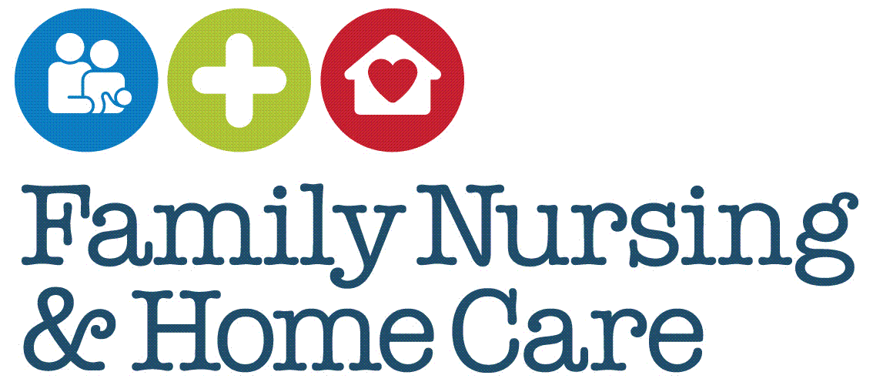

**Standard Operating Procedures**

**Fundraising Activities**

July 2025

**Document Profile**

|  |  |
| --- | --- |
| **Type** | Standard Operating Procedures |
| **Title** | Fundraising Activities |
| **Author(s)** | Mo de Gruchy, Communications Adviser, in collaboration with Fundraising Team |
| **Category** | Corporate |
| **Version** | 1 |
| **Approval Route** | Organisational Governance Approval Group (OGAG) |
| **Date approved** | 2/07/25 |
| **Review date** | 3 years from approval |
| **Document Status** | This is a controlled document. Whilst it may be printed, the electronic version posted on the intranet is the controlled copy. Any printed copies of this document are not controlled. As a controlled document, it should not be saved onto local or network drives but should always be accessed from the intranet. |

**Version Control**

|  |  |  |
| --- | --- | --- |
| **Date** | **Version** | **Summary of changes made** |
| July 2025 | 1 | New SOPs developed to support new Fundraising Policy |
|  |  |  |
|  |  |  |

**Contents**

Introduction 4

SOP 1 Draw Club 5

SOP 2 Processing of Income Streams 8

SOP 3 Acknowledgement of Income Received 10

Appendices 11

Appendix 1 Draw Club Promoter Role and Responsibilities 11

Appendix 2 FNHC Draw Club Application Form 12

Appendix 3 FNHC Draw Club Terms and Conditions 13

Appendix 4 JGC ‘Unusual Event’ Report Form 15

# Introduction

These Standard Operating Procedures (SOPs) relate to FNHC’s regular fundraising activities and should be used in conjunction with the organisational Fundraising Policy.

There are separate SOPs to cover Grants and Legacies.

# SOP 1 Draw Club

|  |
| --- |
| ***Purpose*** |

This SOP gives details of the process to follow when running the annual Draw Club

|  |
| --- |
| ***Scope*** |

Relevant Fundraising staff

|  |
| --- |
| ***Core Requirements/Procedure*** |

**Registration and Permit**

Ensure that the Jersey Gambling Commission Permit authorising the Draw Club for a calendar year has been applied for and received by the designated Promoter (permit holder). After completion of the event the Permit Holder is required to submit a Regulatory Return to the Commission (see appendix 1).

**Ticket Application**

All applicants are required to complete the FNHC ticket application form (Appendix 2).

Applicants can apply via the website - age verification is supported by YOTI.

Applicants can request a form by:

* Collecting in person, at FHNC main premises at Le Bas Centre, St Saviours Road, St Helier
* Telephone/Email the Fundraising department to request an application form
* Downloading an application form from the FNHC website or complete online

All applicants must read and sign the completed application form agreeing that they have read the Terms & Conditions (Appendix 3) and that the following details are correct:

* Name
* Address
* Contact Number
* Email Address
* Date of Birth (DOB) provided *
* Jersey residency confirmed

Completed form to be returned to FNHC with payment method i.e. Cheque/Card/Direct Debit details. Tickets can also be purchased and paid for online.

*FNHC is required to age verify each new applicant either in person or via the ‘Yoti’app. This is to confirm that they are over the age of 18. Anyone appearing to look under 25 will be asked to provide proof of DOB.

**Ticket Allocation – new player**

The Donorflex operator checks that all the information is correct on the submitted application form

The Donorflex operator confirms that the applicant is a Jersey resident (a local address will be on Donorflex and must be confirmed for a ticket to be issued).

The ticket is processed and the applicant is added as a new Draw Club player and credit is added to the chosen Draw Club number/numbers

The Donorflex operator will be alerted if a number is already in existence ensuring that ticket/s are not duplicated

The Donorflex operator then processes payment and application

A ticket number is then allocated to the applicant

Once the application, payment and allocation of a number is complete the applicant then becomes a New Draw Club Player

The Donorflex operator creates a letter and includes the ticket which is sent to the address given on Donorflex

Date of entry into the monthly Draw Club is dependent upon receipt of the application form and payment or no less than two working days prior to the draw

*NB: If the club member has paid by credit/debit card, on request their receipt will be included with the letter and ticket posted to them*

**Ticket Allocation – existing player**

If needed, the user updates Donorflex should any details have changed (i.e. address/phone number/email)

The Donorflex operator checks that the applicant has a membership number on the system

If the applicant is an existing club player, the ticket is processed and credit is added to the chosen Draw Club number/numbers

**Monthly Draw**

The Draw Club is drawn on the last Friday of the month via Donorflex Draw Club module

Present at the draw will be two trained and authorised Donorflex operators plus the promoter. In the event that the promoter is unavailable i.e. annual leave, the CEO or other designated person will attend and witness the draw

Winners are selected randomly by Donorflex and winning numbers are recorded on the system

The winners are contacted by phone (or by post if they are not contactable by phone) and asked to verify name, address and date of birth.

If it is identified that there has been a data entry error e.g. address or telephone number is incorrect, the Donorflex operator will refer back to the application form to clarify information given

Winners cheques will be posted to their address Cheques are issued in line with FNHC financial regulations

In the event of a winner being uncontactable the prize money is kept for a period of six months from the date of the relevant draw and any prize money not claimed becomes the property of Family Nursing & Home Care

**Underage gambling**

FNHC will undertake all necessary procedures to ensure players are aged 18.

Applicants for the Draw Club must provide a date of birth and confirm the fact they are a Jersey resident on their application form through ticking a box provided and signing the application form

If the FNHC suspects a club player is under 18 years of age, under the Terms & Conditions of the ticket purchase, the fundraising staff will immediately cancel the ticket and advise the Promoter

The ticket number will be voided on the Donorflex system and no winnings will be paid out.

FNHC will in turn advise the Jersey Gambling Commission (JGC) of the incident and complete the Unusual Event Report Form (Appendix 4)

# SOP 2 Processing of Income Streams

|  |
| --- |
| ***Purpose*** |

This SOP gives guidance on how to process various income streams

|  |
| --- |
| ***Scope*** |

Relevant Fundraising staff

|  |
| --- |
| ***Core Requirements/Procedure*** |

All income received by FNHC is documented on a control spreadsheet. The value of each sum is cross checked by the Finance and Fundraising teams to ensure it matches the amount entered on Donorflex.

The process to follow for each payment type is outlined below:

**Cheques**

Establish relevant category of donation e.g. General Donation/In Memory Of etc.

Check cheque details are correct – if any discrepancies contact individual and ask them to provide a replacement cheque

Enter details onto control spreadsheet and Donorflex

Pass cheque to Finance to process

**Cash**

Cash counted by two people and amount recorded on the control spreadsheet and Donorflex

Cash transferred securely to Finance

**Credit/debit card payments**

In person at FNHC office – take payment on card machine and give receipt to individual

Over the phone – take payment on card machine and scan copy of receipt onto Donorflex

Enter transaction details onto control spreadsheet and Donorflex

**Payments via BACS/Race Nation/Just Giving/Eventbrite/City Pay**

Finance team check bank statement daily and document all income onto control spreadsheet, including from the above sources

Fundraising team receive a report from each source of income e.g. Race Nation and share this information with Finance and add details to Donorflex

**Payments received via Direct Debit**

Finance team receive report from Access Pay Suite giving details of all direct debits received. This information is shared with the Fundraising team.

Details of transactions entered onto control spreadsheet and Donorflex

In the case of any rejected direct debits, these details will be logged on the control spreadsheet and Donorflex in order to cancel future incoming payments

**Jersey Gift Support (Income Tax repayment)**

FNHC can claim tax back on donations of £50.00 or more

Fundraising will send out a Jersey Gift Support form to the donor

Once the completed form is returned the information is added to the “Lump Sum Donation Schedule” spreadsheet supplied by the Income Tax Department

The completed form is scanned into the donor record. The form is then kept in a folder marked “Tax Form Returns”

The completed spreadsheet is sent to Income Tax Department annually, with completed forms kept securely in case they are requested by Income Tax Department

# SOP 3 Acknowledgement of Income Received

|  |
| --- |
| ***Purpose*** |

This SOP gives guidance on the procedure for acknowledging income received from donations

|  |
| --- |
| ***Scope*** |

Relevant Fundraising staff

|  |
| --- |
| ***Core Requirements/Procedure*** |

**All Donations**

Once processed, send out a ‘Thank You’ letter to individual/company within 4 weeks

If the value of the donation exceeds £500, the ‘Thank You’ letter will be signed by the CEO

# Appendices

# Appendix 1 Draw Club Promoter Role and Responsibilities

The role will be designated to a senior member of staff selected by the CEO.

They are responsible for:

* being the designated person who will communicate with the Jersey Gambling Commission (JGC)
* informing the JGC if the promoter is not available and advise of a named designated person
* informing the JGC if there are any incidents i.e. identification of underage gambling
* determining appropriate administrative arrangements to ensure that the FNHC Draw Club is controlled properly and remains within the law
* ensuring that before proceeding with the Draw Club that adequate record keeping and financial accounting procedures are in place
* being aware of details of winners and winning tickets
* ensure staff involved in the Draw Club adhere to FNHC Information Governance policies

# Appendix 2 FNHC Draw Club Application Form

# Appendix 3 FNHC Draw Club Terms and Conditions

The Draw Club is promoted by Family Nursing & Home Care, a Charitable Organisation and is regulated by the JGC.

There are twelve prizes each month one each of £1,000, £500, £250 and nine prizes of £30.

The total number of Draw Club tickets available at any time in 2025 is 2025 tickets numbered sequentially from 1 to 2025.

Tickets can only be purchased by adults aged 18 years and over. Any ticket holder found to be under 18 years of age will be removed from the monthly draws and will automatically forfeit the right to claim a prize. FNHC will refund the ticket price and report the incident to the JGC.

Ticket holders must be a Jersey resident.

**Age verification is required by Family Nursing & Home Care.**

When purchasing a ticket, players acknowledge that Family Nursing & Home Care reserves the right to undertake any age verification checks it deems necessary including the use of third party where appropriate.

YOTI online – through FNHC website

Paper form (either through downloading from website or request from FNHC) will require the individual to be age verified in person with passport or driving licence.

Tickets cost £2.50 per month (£30 a year) and each unique ticket number will be entered into a monthly draw provided that payment in full has been received prior to monthly draw. Only tickets for which full payment has been received at the date of the monthly draw are eligible to win the prizes.

**Direct debit payers**: If a direct debit payment is not received for full ticket price on or before the agreed date, the ticket holder will be notified by phone (or email or post if not contactable by phone) that payment has not been received and therefore their ticket will not be entered into any of the monthly draws.

The ticket holder is responsible for providing Family Nursing & Home Care with accurate and up to date contact details, including their name and address and the ticket holder shall inform Family Nursing & Home Care of any changes to these details.

The monthly draw will take place at Family Nursing & Home Care, Le Bas Centre, St Saviours Road, St Helier, JE2 4RP on the last Friday of the month. The lottery will only be cancelled or significantly delayed with good reason. All participants will be notified, and ticket money returned if needed.

Any individual may hold more than one Draw Club ticket but a maximum of 10.

Prize winners will be notified by phone (or email or post if not contactable by phone). A cheque will be posted to each of the winners.

Prizes must be claimed within 6 months of the relevant draw and any prize money not claimed becomes the property of Family Nursing & Home Care.

Results of each draw are published on the Family Nursing & Home Care website at www.fnhc.org.je and social media.

Family Nursing & Home Care will use the player’s personal data for the purposes of administering their participation in the monthly draw and communicating with them about their purchase. The details of each winner must also be shared with JGC for regulatory purposes. JGC may contact our winners to confirm that this data is accurate.

If a charity becomes insolvent, ticket buyers will be reimbursed £2.50 for each month of the year that the lottery will not be taking place. The charity will ensure that sufficient funds are available to reimburse ticket holders as required.

Any changes to the rules of the lottery will be shared with ticket buyers.

Family Nursing & Home Care staff are able to purchase tickets with the exception of the Promotor.

# Appendix 4 JGC ‘Unusual Event’ Report Form

This form should be used when reporting either:

* An Event that was NOT notified to the Commission and required either a Licence, Permit or Registration

OR

* When reporting an irregularity at an Event held under a Licence, Permit or Registration.

Click on this link to access the form [CSFR01 - 01/14 (jgc.je)](https://www.jgc.je/assets/uploads/All/Unusual-Event-Report-CHARITABLE.pdf)