

**Standard Operating Procedures**

**MECSH Mental Health Practitioner**

August 2025

**Document Profile**

|  |  |
| --- | --- |
| **Type** | Standard Operating Procedures |
| **Title** | MESCH Mental Health Practitioner |
| **Author(s)** | Nicky Le Conte, MECSH Mental Health Practitioner and Michelle Cumming, Operational Lead, Child & Family Division |
| **Category** | Clinical |
| **Version** | 2 |
| **Approval Route** | Organisational Governance Approval Group (OGAG) |
| **Date approved** |  |
| **Review date** | *3 years from approval* |
| **Document Status** | This is a controlled document. Whilst it may be printed, the electronic version posted on the intranet is the controlled copy. Any printed copies of this document are not controlled. As a controlled document, it should not be saved onto local or network drives but should always be accessed from the intranet. |

**Version Control**

|  |  |  |
| --- | --- | --- |
| **Date** | **Version** | **Summary of changes made** |
| February 2022 | 1 | New SOP |
| March 2022 | 1.1 | Minor amendments post-consultation |
| August 2025 | 2 | Full review and general updating, including:   * Page 5, SOP 1 – Change from 6 to 8 one hour sessions – this has been subsequently reflected on pages 9 and 13 as follows:   + Page 9 – SOP 5, Core requirements, 1st para – Change ‘5 visits’ to ‘6-7 visits; and   + Page 13 – Appendix 2, 2nd para – change ‘6 visits’ to ‘6-8 visits’. |

**Contents**

Introduction 5

SOP 1 Role and Purpose of the MECSH MHP Service 6

SOP 2 Referral Process 7

SOP 3 First Visit 8

SOP 4 Initial Assessment 9

SOP 5 Ongoing Sessions 10

SOP 6 Final Visit 11

Appendices 12

Appendix 1 Mental Health Practitioner Referral – MECSH Clients 12

Appendix 2 Template Letter to GP. 16

Appendix 3 EPDS Questionnaire 17

Appendix 4 GAD-7 Questionnaire 18

Appendix 5 PHQ Questionnaire 19

19

Appendix 6 Client Feedback Form 20

# Introduction

Maternal Early Childhood Sustained Home-Visiting (MECSH) is a structured programme of sustained home visiting for families identified to be at risk of poorer maternal and child health and development outcomes. It is delivered as part of a comprehensive, integrated approach to services for young children and their families.

In 2014 Family Nursing & Home Care (FNHC) introduced the MECSH Scheme in Jersey. The programme draws together the best available evidence on the importance of the early years, children’s health and development, the types of support parents need, parent-infant interaction and holistic, ecological approaches to supporting families to establish the foundations of a positive life trajectory for their children.

Key components of the scheme include:

* Supporting mother and child health and wellbeing
* Supporting mothers to be future oriented and aspirational
* Supporting family and social relationships
* Additional support in response to need
* Child development parent education

The MECSH programme is delivered by a dedicated team of Health Visitors (HV) who have undertaken additional training as MECSH Practitioners with a MECSH Mental Health Practitioner (MHP) working alongside to support MECSH clients who require additional mental health support.

These Standard Operation Procedures (SOPs) have been developed to guide the work of the MECSH Mental Health Practitioner (MHP)

# SOP 1 Role and Purpose of the MECSH MHP Service

|  |
| --- |
| ***Purpose*** |

This SOP outlines the role and purpose of the MECSH MHP Service

|  |
| --- |
| ***Scope*** |

This applies to all members of the MECSH team who may be involved in referring clients to the MHP Service

|  |
| --- |
| ***Core Requirements/Procedure*** |

The MHP Service is a short-term intervention focused on maternal mental health and emotional wellbeing. This is based on a Brief Solution Focused Therapy approach.

It consists of a maximum of eight one-hour sessions which take place in the client’s home. The sessions focus on supporting the client to develop a toolbox of Cognitive Behavioural Therapy (CBT) informed strategies, mindfulness and breathing techniques to support mental health and wellbeing.

During the sessions, if appropriate, onward referral for further psychotherapeutic intervention will be discussed with the client. Also discussed, depending on the severity of the client’s mental health presentation, will be escalation/referral to the JAMHS (Jersey Adult Mental Health Service) Perinatal Mental Health Service (PMHS), which would offer the client a Mental Health Assessment with Perinatal Psychiatrist and support from the PMHS Team.

The MHP will maintain records of client interventions on EMIS and maintain ongoing liaison with referring HVs as required.

As part of their role, the MHP will be required to attend:

* Monthly supervision with MECSH Champion
* Bi-monthly CAMHS Clinical Supervision.

# SOP 2 Referral Process

|  |
| --- |
| ***Purpose*** |

This SOP details the process to be followed when referring a client to the MECSH MHP Service.

|  |
| --- |
| ***Scope*** |

This applies to all members of the MECSH team who may be involved in referring clients to the MHP Service.

|  |
| --- |
| ***Core Requirements/Procedure*** |

The MHP will receive referrals from HVs re clients who are already receiving support through the MECSH programme and where the HV has had a discussion with the client re their maternal mental health and emotional wellbeing.

The HV will have described the MHP Service to the client and how this might benefit them. Client consent will be required before the HV can refer them to the MHP Service.

The HV will complete the Referral Form (Appendix 1) and send it to the MHP, including a current EPDS and GAD Assessment Score (see SOP4)

The MHP will review the Referral and if appropriate for the Service will triage the client.

The MHP will liaise with the referring HV to obtain further background information and organise a joint visit to the client.

The HV will contact the client to confirm details of visit, which will take place in the client’s home environment.

# SOP 3 First Visit

|  |
| --- |
| ***Purpose*** |

This SOP covers the process involved in the first visit.

|  |
| --- |
| ***Scope*** |

This applies to all members of the MECSH team who may be involved in referring clients to the MHP Service.

|  |
| --- |
| ***Core Requirements/Procedure*** |

The first visit will take place in the client’s home and will be a joint visit with the client’s HV and the MHP. In some circumstances (i.e. leave) the MHP may conduct the first visit alone, after establishing contact and discussing this with the client.

The MHP will explain the purpose and content of the Service they can provide (as per SOP 1).

The MHP will discuss with the client regarding their current mental health needs, recent history, presenting problems and what the client wished to achieve, using a collaborative approach.

The MHP will ensure she has the client’s email address and mobile number to support communication relating to appointment times.

The MHP will write to the client’s GP to inform them of the MHP’s involvement in their patient’s care (see Appendix 2)

# SOP 4 Initial Assessment

|  |
| --- |
| ***Purpose*** |

This SOP covers the process involved in the Initial Assessment

|  |
| --- |
| ***Scope*** |

This applies to all members of the MECSH team who may be involved in referring clients to the MHP Service.

|  |
| --- |
| ***Core Requirements/Procedure*** |

The MHP will complete an Initial Assessment in the client’s home environment, allowing 90 minutes to complete the process.

The MHP will complete a full assessment of the client’s mental health needs, including the client’s perception of their main difficulties at present, significant stressors and how this is impacting their life at present.

The MHP will also obtain information on the mental health history of the client and of the client’s family and complete a Risk Assessment. The client will be asked to complete the following to obtain a baseline score (See Appendices 3 – 5):

* Edinburgh Postnatal Depression Scale (EPDS)
* Generalised Anxiety Disorder Assessment (GAD-7)
* Patient Health Questionnaire (PHQ-9)

The MHP and the client will agree specific goals of treatment.

The MHP will reflect on the client’s aspirations and discuss with the client to ensure that this is the right time for intervention for them, to support positive outcomes.

The MHP will explain to the client that confidentiality will be maintained and will obtain consent from the client for the MHP to liaise/share information with other Health Care Professionals – where this is required it will be on a ‘need to know’ basis. Following this session and clarification of presenting issues the MHP will email psychoeducation** to the client.

**Psychoeducation is an evidence-based therapeutic intervention for patients and their loved ones that provides information and support to help them better understand and cope with their mental health condition.

# SOP 5 Ongoing Sessions

|  |
| --- |
| ***Purpose*** |

This SOP covers the process involved in the ongoing sessions.

.

|  |
| --- |
| ***Scope*** |

This applies to all members of the MECSH team who may be involved in referring clients to the MHP Service.

|  |
| --- |
| ***Core Requirements/Procedure*** |

The MHP will continue to visit the client at home for a further 6/7 visits or one hour each. Where possible, these visits will be weekly for visits one and two and then fortnightly or at a variable frequency according to the client’s mental health needs.

During these sessions the regular focus will be on the client’s mental health presentation and also their aspirations, goals and a review of the effectiveness of specific strategies. If appropriate the MHP will discuss with the client possible joint sessions with the client’s partner or significant other member of the client’s family/support system.

There will be ongoing review of psychoeducation provided, and referrals made to other Services, where this has been indicated.

# SOP 6 Final Visit

|  |
| --- |
| ***Purpose*** |

This SOP covers the process involved in the final visit.

|  |
| --- |
| ***Scope*** |

This applies to all members of the MECSH team who may be involved in referring clients to the MHP Service.

|  |
| --- |
| ***Core Requirements/Procedure*** |

The client will be asked to complete the following again to obtain a score for comparison:

* Edinburgh Postnatal Depression Scale (EPDS)
* Generalised Anxiety Disorder Assessment (GAD-7)
* Patient Health Questionnaire (PHQ-9)

The MHP and client will review the client’s mental health presentation and their aspirations, goals and effectiveness of strategies.

The client will be ‘discharged’ from the MHP Service. Depending on outcomes the client will be:

* Returned to the MECSH programme under the care of their HV
* Referred to other agencies for ongoing psychotherapeutic support

The MHP will ask the client to complete a Feedback Form (see Appendix 6). The data collected is included in the overall MECSH report.

# 

# Appendices

# Appendix 1 Mental Health Practitioner Referral – MECSH Clients

**Name of household members/significant others.**

|  |  |  |
| --- | --- | --- |
| Mother | DOB | Address |
|  |  |  |
| EMIS Number | Tel details. |  |
|  |  |  |
| Father | DOB | Address |
|  |  |  |
| EMIS Number | Tel details. |  |
| Child: |  |  |
| Child: |  |  |
| Child: |  |  |

|  |  |
| --- | --- |
| Preferred language. |  |
| Interpreter required. |  |
| Communication issues. |  |

|  |  |
| --- | --- |
| Pregnant. Gestation. | Weeks - |
| PIM | YES  NO |
| Baby Steps attendee | YES  NO |
| Adult mental Health referral? |  |
| Other therapy |  |

|  |  |
| --- | --- |
| Midwife |  |
| GP |  |
| Referred by. | Tel: |
| Date of referral. |  |

|  |  |
| --- | --- |
| Any other professionals/ agencies involved. |  |
| Details. |  |

|  |  |
| --- | --- |
| Reason for referral |  |
| EPDS Dates | SCORE |
| GAD 7 Dates | SCORE |

|  |
| --- |
| **Mental health and current presentation**. |
|  |

|  |
| --- |
| **Mental Health History: to include previous psychiatric illness/treatment and family history.** |
|  |
| **Client perceptions-what interventions would the client find helpful?** |
| * Anxiety management * Support with depression/low mood. * Other: please specify. |
| **Client voice:** |

|  |
| --- |
| **Substance misuse – i.e. alcohol use** |

|  |
| --- |
| **Any Risk issues i.e. domestic abuse /self-harm.** |
| **Safeguarding concerns- Brief summary.** |

# Appendix 2 Template Letter to GP

Date

GP Address

Client Name: D.O.B:

I am writing to inform you that the above Client is participating in the Health Visiting MECSH (Maternal Early Childhood Sustained Home Visiting) Programme.

I am offering sessional therapeutic support within the home, in my capacity as Mental Health Practitioner for 6-8 visits, focusing on the Client’s mental health and wellbeing.

Should you have any significant information regarding this Client’s mental health history, please do not hesitate to contact me – detailed below.

I will liaise with you, should there be any concerns in the meantime.

Yours sincerely

Nicky Le Conte

Mental Health Practitioner

Tel: 497606

Email: n.leconte@fhnc.org.je

MECSH Programme

# Appendix 3 EPDS Questionnaire

# Appendix 4 GAD-7 Questionnaire

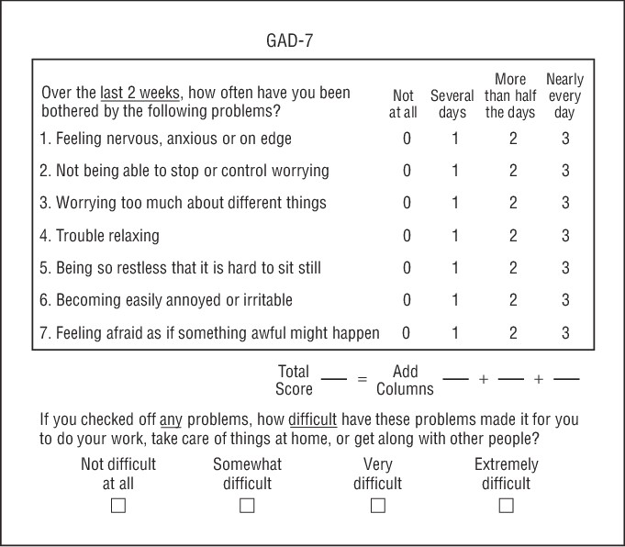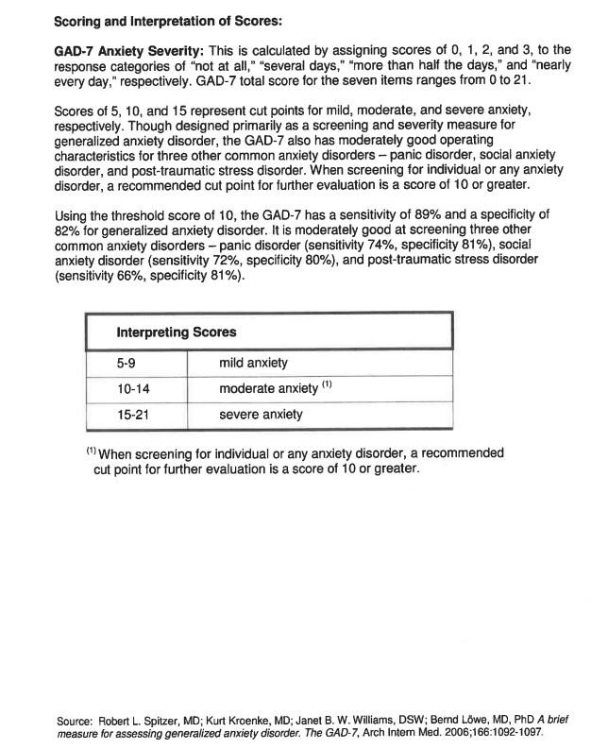

# Appendix 5 PHQ Questionnaire

# Appendix 6 Client Feedback Form

