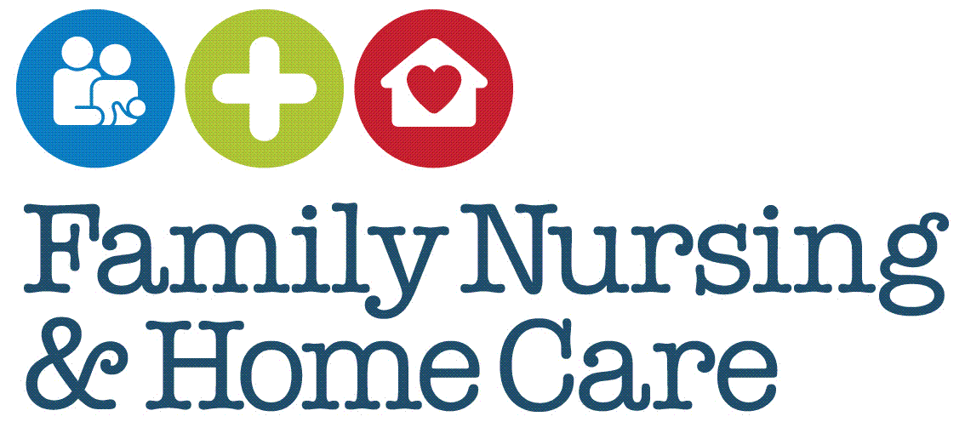

**Standard Operating Procedures**

**MECSH Programme**

August 2025

**Document Profile**

|  |  |
| --- | --- |
| **Type** | Standard Operating Procedures |
| **Title** | MECSH Programme |
| **Author(s)** | *Marie Raliegh updated by Claire Harvey MECSH Champion* |
| **Category** | Clinical |
| **Version** | 2 |
| **Approval Route** | Organisational Governance Approval Group (OGAG) |
| **Date approved** | 6th August 2025 |
| **Review date** | 6th August 2030 |
| **Document Status** | This is a controlled document. Whilst it may be printed, the electronic version posted on the intranet is the controlled copy. Any printed copies of this document are not controlled. As a controlled document, it should not be saved onto local or network drives but should always be accessed from the intranet. |

**Version Control**

|  |  |  |
| --- | --- | --- |
| **Date** | **Version** | **Summary of changes made** |
| April 2022 | 1 | New SOP |
| xxx 2025 | 2 | Updated MECSH SOPs |
|  |  |  |
|  |  |  |

**Contents**

Introduction 4

SOP 1 Programme Outline and Client Eligibility 6

SOP 2 Programme Delivery 7

SOP 3 Staff Training 8

SOP 4 Staff Supervision 9

Appendix 1 Eligibility Criteria for access to MECSH 10

Appendix 2 FNHC MECSH Programme Service Schedule 11

Appendix 3 Learning to Communicate Parent Handbook 12

Appendix 4 Promoting First Relationships Handouts 13

Appendix 5 Patient Enablement Instrument (PEI) Questionnaire and Patient Satisfaction Questionnaire (PSQ) QR code 14

Appendix 6 Adapt and Self Manage (ASM) Questionnaire QR code 15

# Introduction

Maternal Early Childhood Sustained Home-Visiting (MECSH) is a structured programme of sustained nurse home visiting for families identified to be at risk of poorer maternal and child health and development outcomes. It is delivered as part of a comprehensive, integrated approach to services for young children and their families.

MECSH was originally developed and is licenced by the University of New South Wales (UNSW) in Australia. Organisations are provided with support through the licence and implementation support package. Granting of a licence signifies a commitment by the licenced service to delivery of a quality intervention and service systems to meet the needs of vulnerable families in their community.

Key components of the scheme include:

* Supporting mother and child health and wellbeing
* Supporting mothers to be future oriented and aspirational
* Supporting family and social relationships
* Additional support in response to need
* Child development parent education

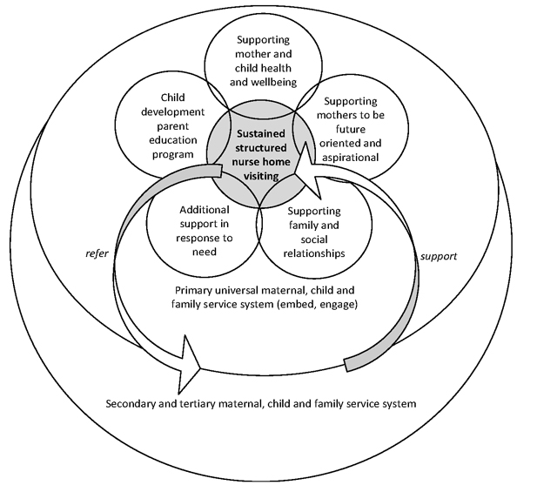

In 2015 Family Nursing & Home Care (FNHC) introduced the MECSH Programme in Jersey, commissioned by the Government of Jersey. The programme draws together the best available evidence on the importance of the early years, children’s health and development, the types of support parents need, parent-infant interaction and holistic, ecological approaches to supporting families to establish the foundations of a positive life trajectory for their children.

The MECSH programme is delivered by a dedicated team of Health Visitors (HVs) who have undertaken additional training as MECSH Practitioners.

A MECSH Mental Health Practitioner (MHP) works alongside to support MECSH clients who require additional mental health support (as per MECSH MHP SOPs).

Community Staff Nurses, Health Practitioners and Community Nursery Nurses also support the delivery of the model under the supervision of the named HV.

These Standard Operating Procedures (SOPs) have been developed to support delivery of the MECSH Programme.

# SOP 1 Programme Outline and Client Eligibility

|  |
| --- |
| ***Purpose*** |

This SOP outlines the MECSH Programme and client eligibility.

|  |
| --- |
| ***Scope*** |

This SOP applies to MECSH Practitioners and members of the skill mix team involved in the delivery of the MECSH Programme to parents and families.

|  |
| --- |
| ***Core Requirements/Procedure*** |

MECSH is an early intervention programme that supports best outcomes for mothers, parents, children and families. The caseload build, client relational engagement, fidelity to visiting pattern and delivery of the programme by trained HV practitioners is key to the programme outcomes. FNHC delivers the MECSH programme under licence from UNSW.

Access onto the programme is through the named Health Visitor for the family. They will discuss access to the programme with the mother/father/parent in detail, so a decision is made together around the support available to the family for the first two years of the child's life.

The offer of MECSH intervention to eligible mothers/parents and families is available from 20 weeks of pregnancy up to eight weeks post discharge from hospital.

Eligibility is based on population screening and assessment which is conducted for all pregnant mothers. Mothers are assessed to be eligible for the offer of MECSH if they meet specific criteria (Appendix 1) and:

* as an outcome of the HV’s professional assessment of the client’s eligibility
* that the client and the HV have assessed the aspiration to be on the programme and understand the aim is to achieve the best outcomes for the parents and child
* that the offer is from 20 weeks of pregnancy and up to eight weeks of age and is a ‘soft offer’ as eligibility is assessed by the HV over time

# SOP 2 Programme Delivery

|  |
| --- |
| ***Purpose*** |

This SOP outlines the delivery of the programme and the requirements to meet the fidelity of the licence

|  |
| --- |
| ***Scope*** |

This SOP applies to MECSH Practitioners and members of the skill mix team involved in the delivery of the MECSH Programme to parents and families

|  |
| --- |
| ***Core Requirements/Procedure*** |

The family participating on MECSH is offered a named HV (MECSH Practitioner) who will work with them throughout the two-year delivery of the programme. Each Practitioner will follow the guidance as set out in FNHC MECSH Programme Service Schedule, a copy of which is issued to all MECSH Practitioners (Appendix 2).

Other key members of the Health Visiting team such the MECSH Mental Health Practitioner (MHP), Community Staff Nurse (CSN), Health Practitioners (HP) and Community Nursery Nurse (CCN) will support the programme at specific times. This will be with oversight of the named HV.

The programme is based on a bio-socio-ecological model and consists of structured antenatal and postnatal home visits alongside group activities and integrated educational programmes such as Learning to Communicate and promoting Health relationships. Parents will be given a Learning to Communicate Parent Handbook (Appendix 3) to help them to develop their child’s communication skills during their first 12 months. Parents will be given printed or emailed handouts to be discussed as part of the Promoting First Relationships module (Appendix 4)

Questionnaires such as the Parent Satisfaction Questionnaire (PSQ), Parent Enablement Instrument (PEI) (Appendix 5) and the Ability to Adapt and Self Manage (ASM) Questionnaire (Appendix 6) are integral to the programme and clients will be requested to complete these at identified intervals.

The programme can be ended at the client’s request. An ASM Questionnaire should be completed with the client and reasons for leaving the programme early will be captured on EMIS. The HV Team Lead should be made aware of any safeguarding concerns and Endings should be discussed in supervision (see SOP 4).

# SOP 3 Staff Training

|  |
| --- |
| ***Purpose*** |

This SOP covers the staff training requirements of the MECSH Programme.

|  |
| --- |
| ***Scope*** |

This SOP applies to MECSH Practitioners and members of the skill mix team involved in the delivery of the MECSH Programme to parents and families

|  |
| --- |
| ***Core Requirements/Procedure*** |

All newly appointed members of the HV team are offered a session with the MECSH Lead to introduce them to the Programme, its aims and objectives.

All HVs will complete two of six MECSH e-learning sessions prior to attending specific two-day face to face MECSH participatory training. Attendance is for those who deliver the programme and who support the programme i.e. Staff nurses, health practitioners and Community Nursery Nurses.

Staff delivering the MECSH Programme are required to complete the six-module e-learning MECSH training within six months of receipt of the two-day face to face training.

Once training is completed HVs will build their MECSH caseload slowly and steadily over time with each HV taking on two new clients per calendar quarter. Over a two-year period, an expected caseload would be 18 clients at the maximum.

Support will be available from the Health Visitor Team Lead and MECSH trained colleagues and supervision as required further to the mandatory supervision sessions (see SOP 4).

Staff will be encouraged to attend any MECSH events delivered by the local MECSH Lead or visiting UK/Australian MECSH Leads.

Staff will be encouraged to read and/or contribute to the ‘MECSH Brief’ professional journal

# SOP 4 Staff Supervision

|  |
| --- |
| ***Purpose*** |

This SOP gives details of the staff supervision requirements of the MECSH Programme Licence to support the fidelity and integrity of the programme

|  |
| --- |
| ***Scope*** |

This SOP applies to MECSH Practitioners and members of the skill mix team involved in the delivery of the MECSH Programme to parents and families

|  |
| --- |
| ***Core Requirements/Procedure*** |

The licence requirement is that all HVs attend a total of eight mandatory MECSH supervision sessions per year - six group sessions and two 1 to 1 sessions.

Regular supervision sessions are arranged by the MECSH trained supervisors and MECSH Lead. These are held in group sessions lasting at least an hour. The invitation to these sessions can be extended to other staff that support the programme and is optional.

Supervision includes two one to one sessions with the MECSH Lead to discuss specific casework or overall management and delivery of the programme.

The MECSH Mental Health Practitioner will receive monthly 1 to 1 supervision sessions with the MECSH Champion, as well as bi-monthly supervision with a CAMHS psychologist.

The MECSH supervisor/supervisee oversees the fidelity and approach of the MECSH model and supports practitioners in using MECSH tools that support programme delivery. This aims to:

Encourage reflection on engagement with families

Encourage a solution focused approach to supporting families experiencing challenges

Develop an approach that enables families to identify and respond to difficulties in the future

Practitioners can also book additional supervision at other agreed times, to discuss MECSH client work.

All the above attendance is captured and submitted to the University of Western Sydney research site as part of the licence agreement. Attendance is captured via this link <https://survey.alchemer.com/s3/6422454/Jersey-Staff-Supervision-Survey>

# Appendix 1 Eligibility Criteria for access to MECSH

|  |  |  |
| --- | --- | --- |
| **CRITERIA for access to the MECSH programme**   * From 20 weeks gestation to eight weeks post-delivery /discharge from hospital. * Maternal aspiration * Meet criteria identified below. | | Comment |
| 1 | (a) There were serious complications during birth  (b) There was separation from the baby after the birth because of health-related issues |  |
| 2 | Either parent is under 21 years of age |  |
| 3 | Either partner is not biologically related to the child i.e. surrogate parents, reformed families etc. |  |
| 4 | There are multiple births or less than 18 months between births of new-born and previous child |  |
| 5 | There is a child with physical or mental disabilities/challenges |  |
| 6 | Parent(s) feel isolated with no one to turn to. |  |
| 7 | There are serious financial problems |  |
| 8 | Mother or partner have been treated for mental illness or depression.  Mother or partner have concerns about their mental health and want long term support. |  |
| 9 | Parent (s) have a dependency on drugs or alcohol. |  |
| 10 | Mother or partner were physically, sexually, emotionally abused as a child |  |
| 11 | Infant is (a) seriously ill (b) premature (c) weighed under 2.5kgs at birth |  |
| 12 | Single parent |  |
| 13 | There is an adult in the house with violent tendencies |  |
| 14 | Either parent/partner are having indifferent feelings about the baby |  |
| Other relevant factors | Smoking in pregnancy  Single adult household |  |

# Appendix 2 FNHC MECSH Programme Service Schedule

# Appendix 3 Learning to Communicate Parent Handbook

Learning to communicate video link <http://www.learningtocommunicate.com.au>

# Appendix 4 Promoting First Relationships Handouts

Accessed from staff’s individual MECSH Scoodle accounts

# Appendix 5 Patient Enablement Instrument (PEI) Questionnaire and Patient Satisfaction Questionnaire (PSQ) QR code

# Appendix 6 Adapt and Self Manage (ASM) Questionnaire QR code

