

**Maintaining Cold Chain of Medicines Policy and Procedures**

**November 2024**

**Document Profile**

|  |  |  |
| --- | --- | --- |
| **Type** | Policy and Procedures | |
| **Title** | Maintaining Cold Chain of Medicines Policy | |
| **Author** | Rachel Foster – Quality and Performance Development Nurse | |
| **Category**  Clinical / Corporate / Education / Health & Safety / Human Resources / Information Governance | | Clinical |
| **Date approved by Organisational Governance Approval Group** | | 7/11/24 |
| **Date approved by Chief Executive Officer** | | 20/11/24 |
| **Review date** | 3 years from approval | |
| **Document Status** | This is a controlled document. Whilst this document may be printed, the electronic version posted on the intranet is the controlled copy. Any printed copies of this document are not controlled. As a controlled document, this document should not be saved onto local or network drives but should always be accessed from the intranet. | |

**Version Control/Changes Made**

|  |  |  |  |
| --- | --- | --- | --- |
| **Date** | **Version** | **Summary of changes** | **Author** |
| November 2024 | 1 | This is a new policy which supersedes the Vaccine Cold Chain Policy and Procedures, 2021. The new policy reflects the operational changes within FNHC whereby School Nurses no longer administer childhood vaccinations. The policy is inclusive of both vaccines and other medications that must be temperature controlled. | Quality and Performance Development Nurse |
| August 2025 | 1.1 | Minor update following the acquisition of a new temperature data logger for the pharmaceutical fridge. Minor amendments to procedure (section 3.2, page 12) | Rachel Foster Quality and Performance Development Nurse |
|  |  |  |  |

**CONTENTS**

1. INTRODUCTION 5

1.1 Rationale 5

1.2 Scope 5

1.3 Role and Responsibilities 5

2. POLICY 6

2.1 Ordering and Monitoring of Stock 6

2.2 Receipt of Stock 6

2.3 Refrigerator 7

2.4 Fridge care and maintenance 7

2.5 Thermometer 8

2.6 Organisation of stock within refrigerator 8

2.7 Storage of reconstituted medicines 9

2.8 Transport of refrigerated medications 9

Use of Cool Boxes and Cool Packs 9

Medication Removal from Fridge 10

Packing and Transportation 10

Upon Arrival 10

Alternative Storage 10

3. PROCEDURES 10

3.1 Access Control to the Pharmaceutical Standard Fridge 10

3.2 Monitoring Temperatures with the data logger 11

3.3 Responding to a cold chain breach or compromised storage event 12

3.4 Response Protocol for Compromised Vaccine Administration 13

3.5 Cleaning the refrigerator 13

4. MONITORING COMPLIANCE 14

5. CONSULTATION PROCESS 15

6. EQUALITY IMPACT STATEMENT 15

6.1 Equality Impact Screening Tool 17

7. IMPLEMENTATION PLAN 18

8. GLOSSARY OF TERMS 18

9. REFERENCES 20

10. APPENDICES 22

10.1 Appendix 1 Guide for medicines fridge temperature check 22

10.2 Appendix 2 Refrigerated Medicines Stability Tool 23

10.3 Appendix 3 Fridge Temperature Monitoring Form 24

10.4 Appendix 4 Flowchart – responding to a cold chain breach 25

10.5 Appendix 5 Example Letter 26

10.6 Appendix 6 Cold Chain Incident Checklist 27

10.7 Appendix 7 Pharmaceutical Standard Fridge Audit Tool 29

10.8 Appendix 9 Cleaning Log 31

# INTRODUCTION

## Rationale

This policy stipulates the process, procedures and equipment required to ensure that medicines requiring cold storage are managed appropriately by Family Nursing & Home Care (FNHC) staff.

As a healthcare provider, FNHC has a legal obligation to ensure the safe storage of medicines. Regulation 14 (2) of the Regulation of Care (Standards and Requirements) (Jersey) Regulations 2018 states that:

*A registered person must protect care receivers from the unsafe use and management of medicines, including by making appropriate arrangements for the safe handling, ordering, storage, security, administration, recording and disposal of medicines.*

To guarantee safety, effectiveness, and adherence to the manufacturer's requirements, it is essential to uphold a temperature range of 2-8 °C throughout the entire journey of certain medications, encompassing storage, transportation, and packaging. This practice, commonly known as "maintaining the cold chain," is crucial.

If the cold chain is disrupted, meaning the medicines are exposed to excessive heat or cold at any point, there is a risk of reduced potency and efficacy, resulting in administration of a sub-optimal medicine. With vaccines, this can require revaccination of patients, which will increase cost for providers / taxpayers and damage the public confidence in vaccines.

## Scope

This policy applies to any FNHC staff who are involved in the handling and management of refrigerated medications.

## Role and Responsibilities

**Chief Executive Officer**

The Chief Executive Officer has ultimate responsibility for ensuring that FNHC has robust governance measures in place to support the safe handling and management of medicines.

**Head of Quality Governance and Care**

The Head of Quality Governance and Care is responsible for ensuring that FNHC has evidence based procedural documents available to ensure the safe handling and management of medicines is followed and that these are reviewed at appropriate intervals. They are also responsible for monitoring any incidents relating to this practice and the implementation of any action required to prevent reoccurrence of untoward incidents.

**Operational Leads**

Operational leads are responsible for ensuring that their teams have access to this policy and for overseeing the monitoring of staff competence and attendance at any training. They also have a responsibility to ensure that any untoward incidents are investigated, and action taken as necessary to mitigate risk.

**Facilities and Premises Manager**

The Facilities and Premises Manager is responsible for ensuring that the pharmaceutical fridge is in good working order and is serviced as appropriate. They are responsible for controlling the access to the fridge and acting upon any concerns around the safety of the fridge and its contents.

**All staff**

All FNHC staff involved in refrigerated medicines handling and management from point of receipt to administration have a responsibility to adhere to this policy and to report any untoward events related to this practice.

# POLICY

## Ordering and Monitoring of Stock

For vaccines – The Government of Jersey’s Health and Community Services (HCS) has responsibility and oversees all vaccine transportation from the UK to the island and must ensure that processes are in place to maintain a Cold Chain to the point of FNHC’s receipt of any vaccines.

Ordering and monitoring of stock levels must be carried out by authorised person(s).

Care must be taken to order the correct quantity. Some medicines present as single dose units whilst others may come as multiple packs or doses. Ordering excess amounts will make it difficult to house if refrigerator storage space is restricted.

Full documentation of all orders placed must be kept for at three years, as per the **FNHC Policy and Procedure for Retention/Destruction of Records**.

It is good practice to carry out and document regular stock checks of the physical quantities against that recorded.

## Receipt of Stock

Staff must ensure they check the following before signing for the medicines:

* verify the received medicines and quantity against the original order, dispatch note, or invoice for any discrepancies
* inspect for any leakage or damage
* confirm that any required security seals are still intact
* ensure there is no reason to suspect that the cold chain has been disrupted

If the person receiving the refrigerated medicine delivery is not assured that the cold chain has been maintained, they should refuse to accept the delivery and return it to the supplier.

Medicines must be refrigerated immediately upon receipt, and not left at room temperature.

Place stock with the longest expiry date at the back. This practice ensures effective stock rotation and prevents medicines from expiring prematurely.

## Refrigerator

Medicines requiring storage between +2°C and +8°C must be kept in a specialised medical refrigerator which is lockable, and possibly equipped with an internal fan. The refrigerator must have a thermometer that records the current, minimum and maximum temperature.

The use of domestic refrigerators for day-to-day storage of medicines is not permitted.

Food, drink and clinical specimens must never be stored in the same refrigerator as medicines.

There must be a named individual and named deputy responsible for monitoring the cold storage of pharmaceutical products and refrigerated medicines.

The refrigerator must be deemed electrically safe for use. It must have a unique identifier, such as a serial number or asset number. Visual inspections and portable appliance testing (PAT) should be undertaken regularly. The Safeguarding of Workers (Electricity at Work) (Jersey) Regulations 1983 require that electrical systems are maintained.

The mains electrical lead should ideally be fitted into a switchless socket. If an on/off switch exists, clear signage is necessary to reduce the probability of accidental interruption of electricity supply.

Refrigerators should be positioned away from radiators or other heat sources that could affect their performance and should be adequately ventilated. To maintain the required temperature, minimise the opening of refrigerator doors.

## Fridge care and maintenance

Fridges must be maintained if they are to continue to be effective.

Annual servicing of refrigerators is recommended to prevent unforeseen malfunctions and minimise wastage. Records of these services must be maintained. The servicing and recording of servicing are undertaken by the Facilities and Premises Manager.

Prevent the build-up of ice within the refrigerator, as this diminishes effectiveness. Regular defrosting is required for refrigerators with ice build-up, and records of defrosting and cleaning activities must be kept. Contingency plans should be in place for defrosting activities.

The fridge seals should be regularly inspected. The seal should not be torn or brittle, and there should be no gaps between the seal and the body of the unit when the door is closed. Check the seal by placing a thin strip of paper against the door seal, close the door, and pull the strip. If the paper falls or comes away easily, then the seal needs to be replaced or adjusted. Check all around the door, particularly the corners. Fridge seal inspection is undertaken by the Facilities and Premises Manager. It is the responsibility of all to report and escalate any noticeable deterioration in the fridge seal.

Cleaning and disinfection of refrigerators as per Procedure 3.5 to prevent mould growth includes:

* wiping the door seals and door seal contact points
* checking for damage to the door seals
* cleaning the drain hole
* dusting the external condenser coils, if accessible

Documentation of the refrigerator cleaning schedule should be maintained by the Facilities and Premises Manager.

## Thermometer

The fridge temperature gauge should be clearly visible to read without needing to open the fridge door.

The fridge should ideally have two thermometers, one of which is a max / min thermometer independent of mains power so temperatures can be measured in the event of electricity loss.

Care should be taken that the thermometer probe cable does not interfere with the door seal, causing the temperature to fall outside the permitted range.

A Data Logger continuously monitors and records the temperature of the fridge which allows for accurate temperature readings. This is particularly useful in the event of a cold chain breach, when staff are trying to establish how long the fridge temperature may have been compromised. The Data Logger must be used according to the manufacturer’s instructions.

If the Data Logger is out of use, temperatures in the fridge are to be monitored and recorded at least once each working day and documented as a maximum, minimum and current reading. Refer to Appendix 1 and 3 for a fridge temperature monitoring form and a guide on how to obtain readings from the fridge’s thermometer.

## Organisation of stock within refrigerator

**Fridge Capacity**: Ensure the fridge is not overstocked; it should not exceed 50% capacity.

**Preventing Freezing**: Avoid direct contact with the back or sides of the fridge to prevent freezing of refrigerated medicines.

**Use of Vented Boxes/Wire Baskets**: Utilise vented boxes or wire baskets to store vaccines and medications within the fridge, promoting organisation and preventing loose items from falling to the back. If using vented boxes/wire baskets, ensure they are loosely packed to allow ample air circulation and prevent crushing damage.

**Shelf Designation**: Designate specific shelves for different medicines; list them on the external part of the fridge to minimise door opening time during searches.

**Individual Storage of Refrigerated medicines**: Remove refrigerated medicines from delivery packaging and store them as individual units in the manufacturer’s original packaging; avoid storing them in cardboard boxes or plastic bags.

**Storage in Manufacturer's Original Packaging**: Store refrigerated medicines in the manufacturer’s original packaging to prevent deterioration, especially for those sensitive to light.

**Proper Rotation of Medication Stock**: Ensure proper rotation of medication stock by placing items with the longest expiry date at the back, prioritising the use of stock with the shortest expiry date.

**Handling Short-Dated Stock**: Clearly label and prioritise the use of short-dated stock.

**Handling Out-of-Date Stock**: Promptly label and remove any out-of-date stock from the refrigerator; dispose of it according to the **FNHC Waste Management Policy**.

**Handling Damaged Medications**: Do not use damaged or compromised vaccine or medication vials or syringes. Immediately remove and label such items, disposing of them according to the **FNHC Waste Management Policy**, or report them as a product defect.

## Storage of reconstituted medicines

Generally, it is not good practice to reconstitute medications in advance, however for some refrigerated medicines, there is a need to reconstitute using a diluent.

Reconstituted medicines should be stored in line with the manufacturer’s instructions.

## Transport of refrigerated medications

To ensure the preservation of the cold chain when transporting medicines from one location to another, FNHC staff must adhere to the following guidelines:

## Use of Cool Boxes and Cool Packs

Before use, cool packs should be stored in accordance with the manufacturer’s instructions, usually at 2°C to 8°C

Ice packs and frozen cool packs should not be used unless the cool box manufacturer’s instructions specifically recommend them. This is because they may create cold spots, and result in the medicines freezing

Use the correct number and size of cool packs as specified by the manufacturer to ensure optimal cooling efficiency.

Domestic cool boxes are strictly prohibited for storing, distributing, or transporting medicines.

Use validated cool boxes (e.g., VaccinePorter®) and cool packs from recognised medical supply companies.

Store validated cool boxes and refrigerated medicine carriers as per the manufacturer’s instructions to maintain their integrity and effectiveness.

## Medication Removal from Fridge

Remove medications from the fridge at the latest possible stage to minimise exposure time outside the fridge and ensure the cold chain is consistently maintained.

## Packing and Transportation

Keep medications in their original packaging during transportation.

Place medications into the cool box/refrigerated medicine carrier with cool packs according to the manufacturer’s instructions. Avoid direct contact between cool packs and refrigerated medicines to prevent potential freezing and destabilisation.

## Upon Arrival

Ideally, place medicines in a Pharmaceutical Standard Fridge upon arrival. Refer to section 2.2 for stock receipt procedures.

## Alternative Storage

If a fridge is unavailable (e.g., for home administration), store medications within the cool box/refrigerated medicine carrier with the lid closed until required.

# PROCEDURES

## Access Control to the Pharmaceutical Standard Fridge

**Authorised key holders**

Access to the Pharmaceutical Standard Fridge is limited to the following:

* Rapid Response personnel
* Children’s Community Nursing staff
* Governance personnel
* Premises & Facilities Manager

**Key Distribution**

Keys will be distributed only to designated key holders mentioned above.

The Premises & Facilities Manager will oversee the distribution and retrieval of keys.

Key holders are responsible for the safekeeping and proper use of their assigned keys.

**Access Protocol**

Key holders must use their designated keys to access the Pharmaceutical Standard Fridge.

Ensure that access is granted only to personnel directly involved in vaccine or refrigerated medicine - related activities.

Keys must be returned immediately after use.

**Lost or Stolen Keys**

Report any lost or stolen keys immediately to the Premises & Facilities Manager.

In the event of a lost or stolen key, the Premises & Facilities Manager will initiate a key replacement process.

## Monitoring Temperatures with the data logger

A Wi-Fi enabled Data Logger is in place to continuously capture the temperature inside the pharmaceutical fridge. Temperature information is recorded every minute, and temperature data is received from the Data Logger every fifteen minutes.

The accompanying software to the Data Logger (EasyLog Cloud App) enables the user to set temperature parameters, view temperature data for up to the last 45 days, and modify alert settings.

The primary user of the Data Logger software is the Facilities and Premises Manager, however, The Head of Health and Safety, Head of Information Governance and Systems and the Quality and Performance Development Nurse will also have access if required in the absence of the Facilities and Premises Manager. No other staff member should have access to the Data Logger software. A brief guide to navigating the software is below.

|  |  |
| --- | --- |
| A screenshot of a computer  AI-generated content may be incorrect.Upon signing in to the Data Logger software, select “View Devices” | A screenshot of a computer  AI-generated content may be incorrect.Two options appear when “View Devices” has been selected. Select “On the Cloud” |
| A screenshot of a computer  AI-generated content may be incorrect.From the home screen, battery life, connectivity level and current fridge temperature are available at-a-glance. (Indicated by the yellow arrows)  To view graphical data for the device, select the box as indicated by the blue arrow. | |

**Event Alerts**

If the temperature recorded by the Data Logger is above 8°Celsius or below 2°Celsius, an alert will be triggered in the form of an email. The email alerts will be sent automatically to the Facilities and Premises Manager and automatically forwarded to the Rapid Response and Reablement Team (RRRT) email address. This will be monitored during working hours by the RRRT Coordinator on duty. It is their responsibility to take the appropriate action as detailed within this policy. (see section 3.3)

In addition to the email alert, there will be an audible alarm emanating from the pharmaceutical fridge. This **must not be ignored**, and it is everyone’s responsibility, upon discovery, to ensure that the RRRT Coordinator on duty is aware.

## Responding to a cold chain breach or compromised storage event

In the event of a suspected breach in the cold chain or identification of potential issues with refrigerated medicine storage, immediate corrective action is imperative. Upon noticing out-of-range temperatures within the Pharmaceutical Standard Fridge, it is important to conduct a rapid assessment to ascertain a possible cause. Potential causes to consider include:

* fridge door left ajar or open
* disruption to the electrical supply
* recent restocking or stock take
* cleaning of the Pharmaceutical Standard Fridge or displacement of the thermometer probe

Wherever possible, prompt action should be taken to rectify the identified fault, and the outcomes of these actions must be documented. In cases where no obvious cause can be identified and rectified, the priority is to safeguard the refrigerated medicines from further damage and/or inadvertent use until a thorough investigation of the incident has been conducted, reported and communicated to the relevant FNHC staff.

The flowchart found in Appendix 4 provides the actions to follow in the case of a cold chain breach or a compromised storage event.

The Cold Chain Incident Checklist, which is referred to in the above flowchart can be found in Appendix 6.

## Response Protocol for Compromised Vaccine Administration

Ensure thorough identification of all patients who have received compromised vaccines.

Compile a list of individuals requiring revaccination to establish a timeframe and highlight those at immediate risk.

Prior to initiating revaccination, develop a clear communication strategy. Communication with patients and the public should be open, honest, and transparent to prevent distress, confusion, or misinterpretation.

Identify or create information resources for patients, considering accessibility needs.

Typically, individual communication, such as written letters (refer to Appendix 5 for a sample letter), is the preferred method to inform patients about vaccine errors or incidents.

Provide follow-up advice and information on whom to contact in the event of adverse reactions for patients who undergo revaccination. Document any adverse events in patient notes and report them to the Medicines & Healthcare Regulatory Authority via the Yellow Card reporting system.

Include documentation of adverse events in the final incident report, as this information may be valuable for the future management of similar vaccine incidents.

## Cleaning the refrigerator

**General requirements**

Wear personal protective equipment (PPE) including disposable gloves and a plastic apron before initiating the cleaning process.

Utilise a general-purpose detergent diluted in warm water (following the dilution rate indicated on the container). Ensure an adequate supply of disposable cloths or paper towels for both washing and drying.

Avoid using abrasive cleaners that may scratch the interior, as this could heighten the risk of contamination.

If the fridge is equipped with removable shelves, take them out and soak them in soapy water for thorough cleaning.

Promptly address and clean up any spills to maintain a hygienic environment.

**Exterior**

Spot clean the exterior as and when required using a disinfectant wipe, paying attention to the door handle, as it is the most frequently touched part of the exterior.

**Interior**

Unplug the fridge and relocate medicines to an alternate fridge, if an alternate fridge is not available, use a validated cool box (e.g., VaccinePorter®) and cool packs from recognised medical supply companies. The relocation of medicines must be undertaken by a clinician familiar with the cold chain.

Wash surfaces and shelves with warm soapy water, removing shelves if possible. Avoid using cleaning chemicals unless specified by the manufacturer's guidelines.

Dry the surfaces with a soft cloth.

Plug the fridge back in and wait until it reaches the recommended temperature (2˚C - 8˚C) before returning refrigerated medicines.

If necessary, defrost the fridge before cleaning the interior. Always Refer to the manufacturer's guidelines for specific instructions.

Ensure to fill out the Cleaning Log (Appendix 9) as documentation confirming the completion of the fridge cleaning process.

# MONITORING COMPLIANCE

Refrigerated medicine storage procedures should be audited at least 12 monthly or more frequently if experiencing cold chain problems using the audit tool in Appendix 8

Refrigerator service records will be maintained.

Data Logger will have a valid calibration certificate.

A cleaning log will be maintained Appendix 9

Any breach of this policy will be reported to senior management, reported on the incident reporting system, and thoroughly investigated.

# CONSULTATION PROCESS

|  |  |  |
| --- | --- | --- |
| **Name** | **Title** | **Date** |
| Elspeth Snowie | Head of Quality and Safety | 21/08/2024 |
| Laura Baker | Premises & Facilities Manager |
| Tia Hall | Registered Manager & Operational Lead for Adult Services |
| Stuart Waddingham | Deputy Operational Lead for Adult Services |
| Ann Morgan | Practice Development Nurse Specialist |
| Michelle Cumming | Registered Manager Child and Family Services |

# EQUALITY IMPACT STATEMENT

Family Nursing & Home Care is committed to ensuring that, as far as is reasonably practicable, the way services are provided to the public and the way staff are treated reflects their individual needs and does not discriminate against individuals or groups on any grounds.

This policy document forms part of a commitment to create a positive culture of respect for all individuals including staff, patients, their families and carers as well as community partners. The intention is to identify, remove or minimise discriminatory practice in the areas of race, disability, gender, sexual orientation, age and ‘religion, belief, faith and spirituality’ as well as to promote positive practice and value the diversity of all individuals and communities.

The Family Nursing & Home Care values underpin everything done in the name of the organisation. They are manifest in the behaviours employees display. The organisation is committed to promoting a culture founded on these values.

**Always:**

* Putting patients first
* Keeping people safe
* Have courage and commitment to do the right thing
* Be accountable, take responsibility and own your actions
* Listen actively
* Check for understanding when you communicate
* Be respectful and treat people with dignity
* Work as a team

This policy should be read and implemented with the Organisational Values in mind at all times. See the Equality Impact Assessment for this policy.

## Equality Impact Screening Tool

|  |  |  |  |  |  |  |  |  |  |  |
| --- | --- | --- | --- | --- | --- | --- | --- | --- | --- | --- |
| **Stage 1 - Screening** | | | | | | | | | | |
| Title of Procedural Document: Maintaining Cold Chain of Medicines Policy | | | | | | | | | | |
| Date of Assessment | | 13/08/2024 | | Responsible Department | | | | | Governance | |
| Completed by | Rachel Foster | | | Job Title | | | Quality and Performance Development Nurse | | | |
| **Does the policy/function affect one group less or more favourably than another on the basis of**: | | | | | | | | | | |
|  | | | | | | **Yes/No** | | **Comments** | | |
| Age | | | | | | No | |  | | |
| Disability  *(Learning disability; physical disability; sensory impairment and/or mental health problems e.g. dementia)* | | | | | | No | |  | | |
| Ethnic Origin *(including hard to reach groups)* | | | | | | No | |  | | |
| Gender reassignment | | | | | | No | |  | | |
| Pregnancy or Maternity | | | | | | No | |  | | |
| Race | | | | | | No | |  | | |
| Sex | | | | | | No | |  | | |
| Religion and Belief | | | | | | No | |  | | |
| Sexual Orientation | | | | | | No | |  | | |
| **If the answer to all of the above questions is NO, the Equality Impact Assessment is complete. If YES, a full impact assessment is required: go on to stage 2.** | | | | | | | | | | |
| **Stage 2 – Full Impact Assessment** | | | | | | | | | | |
| **What is the impact** | | | **Level of Impact** | | **Mitigating Actions**  **(what needs to be done to minimise / remove the impact)** | | | | | **Responsible Officer** |
| N/A | | | N/A | | N/A | | | | | NN |
| **Monitoring of Actions** | | | | | | | | | | |
| The monitoring of actions to mitigate any impact will be undertaken at the appropriate level | | | | | | | | | | |

# IMPLEMENTATION PLAN

|  |  |  |
| --- | --- | --- |
| **Action** | **Responsible Person** | **Planned timeline** |
| Policy to be uploaded to the Procedural Document Library | Education and Development Administrator | Within 2 weeks following ratification |
| Email to all staff | Education and Development Administrator | Within 2 weeks following ratification |
| Upload policy (+/- assessment tool) to Virtual College and allocate to relevant staff | Education and Development Department | Within 2 weeks following ratification |
| Relevant staff to sign (via Virtual College) that they have read and understood policy. | All staff notified via Virtual College. | Within 2 months of notification |

# GLOSSARY OF TERMS

|  |
| --- |
| **Adverse Reaction**  An adverse reaction is an unintended and usually undesirable response to a medication or medical intervention. It can range from mild discomfort to serious harm, and reporting such reactions is crucial for monitoring and enhancing patient safety. |
| **Authorised key holders**  Individuals who have been granted permission and responsibility to access and manage the contents of a pharmaceutical fridge. The fridge likely contains temperature-sensitive medications that require careful storage. They are entrusted with the responsibility of proper access, monitoring, and adherence to regulations related to the storage of pharmaceuticals. |
| **Clinell Universal Wipes**  Clinell Universal Wipes are versatile cleaning and disinfecting wipes designed for various surfaces. It efficiently eliminates bacteria and viruses, including those causing healthcare-associated infections. The wipes are widely used in healthcare and other settings to maintain a hygienic environment. |
| **Cold Chain**  The cold-chain system is the process by which vaccines and medicines are kept within a specific temperature range from the moment of manufacture to the point of administration. |
| **Compromised Vaccine Administration**  Compromised Vaccine Administration refers to situations where the proper and safe process of administering vaccines is jeopardised. This can encompass various issues, including incorrect storage, handling, or administration procedures, which may compromise the efficacy, safety, or integrity of the vaccines. |
| **Cool Boxes and Cool Packs**  Cool Boxes: These are insulated containers designed to maintain a cooler temperature for medications that require refrigeration. They provide a portable solution for storing medications at the recommended temperature during travel or in situations where a traditional refrigerator is not available. Cool boxes for medications often come with special compartments and insulation to protect the drugs from temperature fluctuations.  Cool Packs: These are specifically designed cold packs or gel packs intended for use with medications. Medications that need to be kept cool can be placed alongside these packs in a cooler or insulated container. Cool packs help regulate the temperature and prevent medications from getting too warm, ensuring their stability and effectiveness. |
| **Data Logger**  Temperature data loggers are thermometers that both measure and record the temperature of an environment. Data Logging thermometers provide a quick and easy alternative to taking and recording manual readings, by giving the ability to upload the data onto a computer. Data loggers can measure a variety of attributes such as temperature and humidity depending on the model of data logger. The information can then be transferred to a computer to assist with any reports that are required to be carried out. |
| **Medicines & Healthcare Regulatory Authority**  The Medicines & Healthcare Regulatory Authority (MHRA) is a regulatory body responsible for overseeing the safety, quality, and effectiveness of medicines and medical devices. The MHRA conducts evaluations, approves medications and devices for use, and monitors their safety throughout their lifecycle. It serves to safeguard public health by regulating the pharmaceutical and healthcare industries and providing guidance to healthcare professionals and the public. |
| **Personal Protective Equipment**  Personal Protective Equipment (PPE) is specialised equipment, like masks and gloves, worn to minimise exposure to hazards and ensure safety in various environments, such as healthcare and industrial settings. |
| **Portable Appliance Testing (PAT)**  Portable Appliance Testing (PAT) is a process of checking the safety of electrical appliances to ensure they are suitable for use. In the simplest terms, it involves inspecting and testing portable electrical devices to make sure they are in good condition and won't pose a risk of electric shock or fire. The testing is typically done by a qualified professional, and appliances that pass the test are considered safe for use. PAT helps identify any potential electrical faults or issues, promoting a safer environment. |
| **Reconstituted Medicines**  Reconstituted medicines are medications that come in a powdered or concentrated form and need to be mixed with a liquid (such as water or a diluent) before administration. In the simplest terms, reconstituting a medicine involves combining different components to prepare the medication for use. This process is often necessary for certain drugs to ensure their stability and effectiveness, and it is usually done just before the medication is given to the patient. It's important to follow the specific instructions provided by healthcare professionals or on the medication's label to ensure proper reconstitution and dosage. |
| **Refrigerated Medications**  Refrigerated medications are drugs or pharmaceutical products that need to be stored in a refrigerator to maintain their stability and effectiveness. These medications are often sensitive to temperature and can degrade if exposed to higher temperatures, leading to a loss of potency or potential harm. Keeping them in a controlled, cool environment helps ensure that the medications remain safe and suitable for use. |
| **Yellow Card Reporting System**  The Yellow Card Reporting System is a pharmacovigilance initiative that allows healthcare professionals and the public to report suspected side effects or adverse reactions associated with medications, vaccines, and medical devices. The collected data contributes to ongoing monitoring and assessment of the safety profile of pharmaceuticals and healthcare products, aiding regulatory authorities in taking prompt actions to ensure public safety. |

# REFERENCES

NHS Pharmaceutical Quality Assurance Committee (2022) Understanding why temperature management is important for medicines storage. Last updated January 2023. Last accessed 24.11.2023. <https://www.sps.nhs.uk/articles/understanding-why-temperature-management-is-important-for-medicines-storage/>

Royal Pharmaceutical Society. (2023) Professional guidance on the safe and secure handling of medicines. Appendix A: Storage of medicines in healthcare settings. Last accessed 21.11.23. <https://www.rpharms.com/recognition/setting-professional-standards/safe-and-secure-handling-of-medicines/professional-guidance-on-the-safe-and-secure-handling-of-medicines>

National Institute of Clinical Excellence (2015) Medicines optimisation: the safe and effective use of medicines to enable the best possible outcomes. NICE guideline [NG5] Published 04 March 2015. Last accessed 24.11.23 <https://www.nice.org.uk/guidance/NG5/chapter/1-Recommendations>

Specialist Pharmacy Service (2020) Maintaining the vaccine cold chain in primary care. Version 1.2 Last updated 14 September 2023. Last accessed 24.11.23 <https://www.sps.nhs.uk/articles/maintaining-the-vaccine-cold-chain-in-primary-care/>

UK Health Security Agency (2022) Vaccine incident guidance – Responding to errors in vaccine storage, handling and administration. Last accessed 24.11.23 <https://assets.publishing.service.gov.uk/government/uploads/system/uploads/attachment_data/file/1088780/UKHSA-vaccine-incident-guidance-6-july-2022.pdf>

UK Health Security Agency (2013) Immunisation against infectious diseases – The Green Book. Part 1: principles, practices and procedures, chapter 3 Storage, distribution and disposal of vaccines. Last accessed 24.11.23 <https://assets.publishing.service.gov.uk/government/uploads/system/uploads/attachment_data/file/223753/Green_Book_Chapter_3_v3_0W.pdf>

Government of Jersey Health and Community Services (2020) Procedure for the temperature monitoring of ward / department medicine storage areas. HSS-PP-CG-0479-02. Available via Government of Jersey staff intranet.

Leicestershire Partnership NHS Trust (2021) Maintaining Cold Chain of Medicines Policy, version 5.

Specialist Pharmacy Service (2022) Using a refrigerator or freezer to store medicines. Last updated 12July 2023. Last accessed 30.11.23 <https://www.sps.nhs.uk/articles/using-a-refrigerator-or-freezer-to-store-medicines/>

Specialist Pharmacy Service (2022) Temperature control whilst transporting medicines. Last updated 11 July 2023. Last accessed 30.11.23 <https://www.sps.nhs.uk/articles/temperature-control-whilst-transporting-medicines/>

UK Health Security Agency (2019) Guidance - The use of vaccines that have been temporarily stored outside the recommended temperature range. Last accessed 06.12.23 <https://www.gov.uk/government/publications/vaccines-stored-outside-the-recommended-temperature-range-leaflet/the-use-of-vaccines-that-have-been-temporarily-stored-outside-the-recommended-temperature-range>

Health Service Executive (2023) HSE Guidelines for Maintenance of Cold Chain Pharmaceutical Standard Fridges and Management of Vaccine Stock. Version 4. Last accessed 07.06.23 <https://www.hse.ie/eng/health/immunisation/hcpinfo/vaccineordering/sopnio01.pdf>

# APPENDICES

## Appendix 1 Guide for medicines fridge temperature check

Intellicold® Controller

*Daily Temperature Checks and reset*

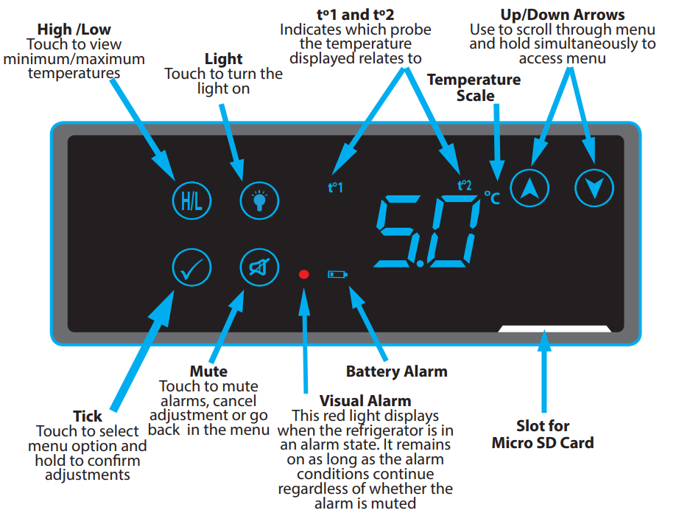

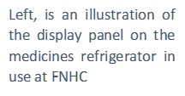

|  |
| --- |
| Min / Max Temperatures  To enable / view functions, first you need to wake the controller menu. This is done by placing your hand for at least two seconds across the controller. This contact will make the buttons / icons visible.  Accessing the Menu |
| 2  Touch the high / low icon and the panel will display the minimum and maximum temperatures recorded. After showing the temperatures, the controller will revert to the normal display and the icons / buttons cease to be active. |
| 3  To reset the minimum / maximum temperatures, hold the high / lowicon / button until flashes on the display. Hold the tick icon / button until the display reverts to the normal temperature screen and the minimum / maximum temperatures can be reset.  Min / Max Reset |

## Appendix 2 Refrigerated Medicines Stability Tool



*Double-click the image to open as a PDF.*

## Appendix 3 Fridge Temperature Monitoring Form



*Double-click the chart to edit in separate document*

## 10.4 Appendix 4 Flowchart – responding to a cold chain breach

(Please also see corresponding SOP)

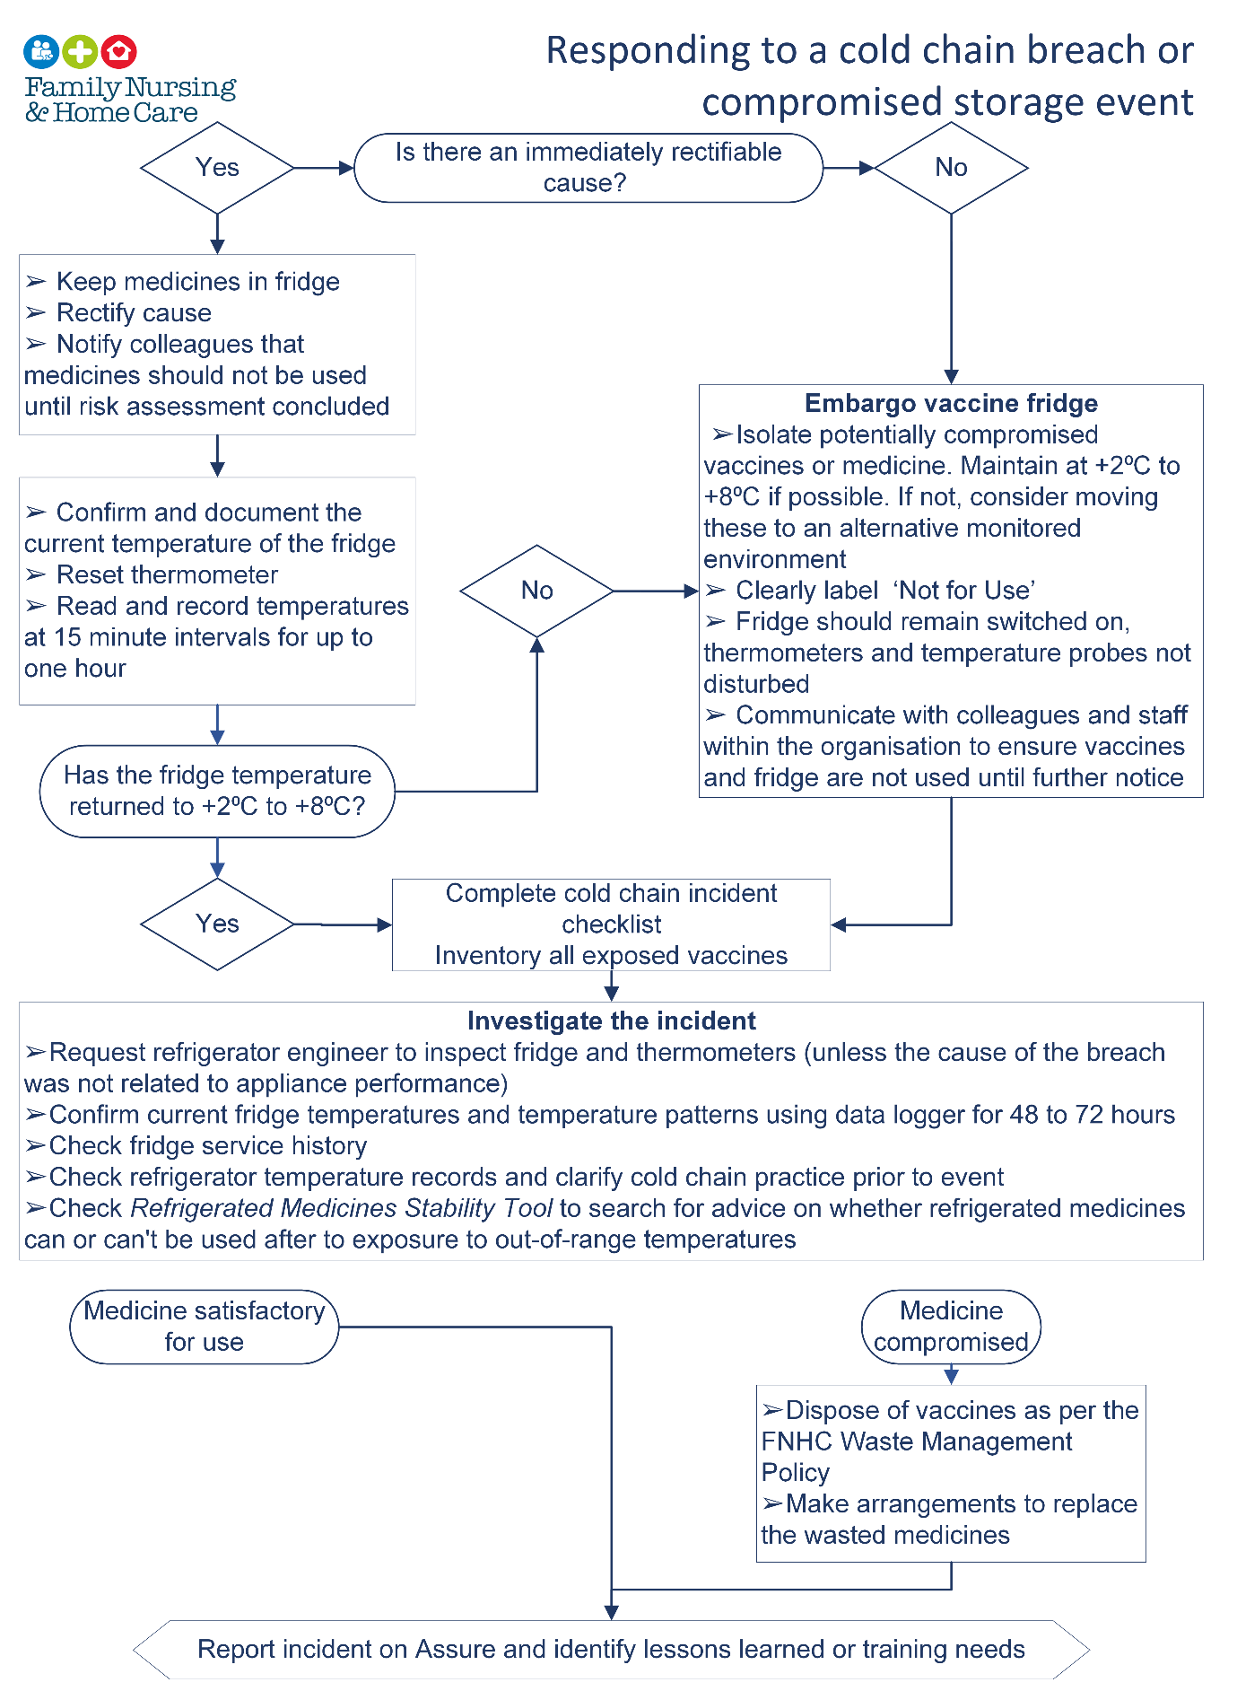

⮚Dispose of medicines as per the FNHC Waste Management Policy

⮚Make arrangements to replace the wasted medicines

**Embargo Medicines Fridge**

⮚Isolate potentially compromised medicines. Maintain +2°C to +8°C if possible. If not, consider moving these to an alternative monitored environment.

⮚Clearly label ‘Not for Use’

⮚Fridge should remain switched on, thermometers and temperature probes not disturbed

⮚Communicate with colleagues and staff within the organisation to ensure medicines and fridge are not used until further notice

## Appendix 5 Example Letter

Example of letter to patient / carer / parent informing of a vaccine that has been administered off-licence and offering revaccination

Example Letter – Vaccine administered which later found to have broken the cold chain

***(Please use the FNHC approved letter template)***

Dear (*patient or carer’s name*)

Re: Vaccines received at (*insert name of clinic or provider*)

I am writing to inform you that we have recently become aware of a problem with the storage* or administration* of the vaccine or vaccines which you* or your child* received at *(insert clinic or provider name*).

As a result of this problem you* or your child* may not gain full protection from this vaccination and we would therefore recommend that you* or your child have a repeat vaccination as soon as possible.

I understand you may have some questions regarding this incident and would ask that you call the provider or clinic on (*insert telephone number*) and make an appointment.

At this appointment we will address any questions you may have regarding the incident and you* or your child* may or will be offered repeat vaccination.

I would like to apologise for any inconvenience or concern this may cause you or your family.

Please be assured that this incident has been fully investigated and every step will be taken to ensure this does not happen again.

Yours sincerely

(Name of registered manager)

*delete as appropriate

## Appendix 6 Cold Chain Incident Checklist



*Double-click the above to edit in separate document*

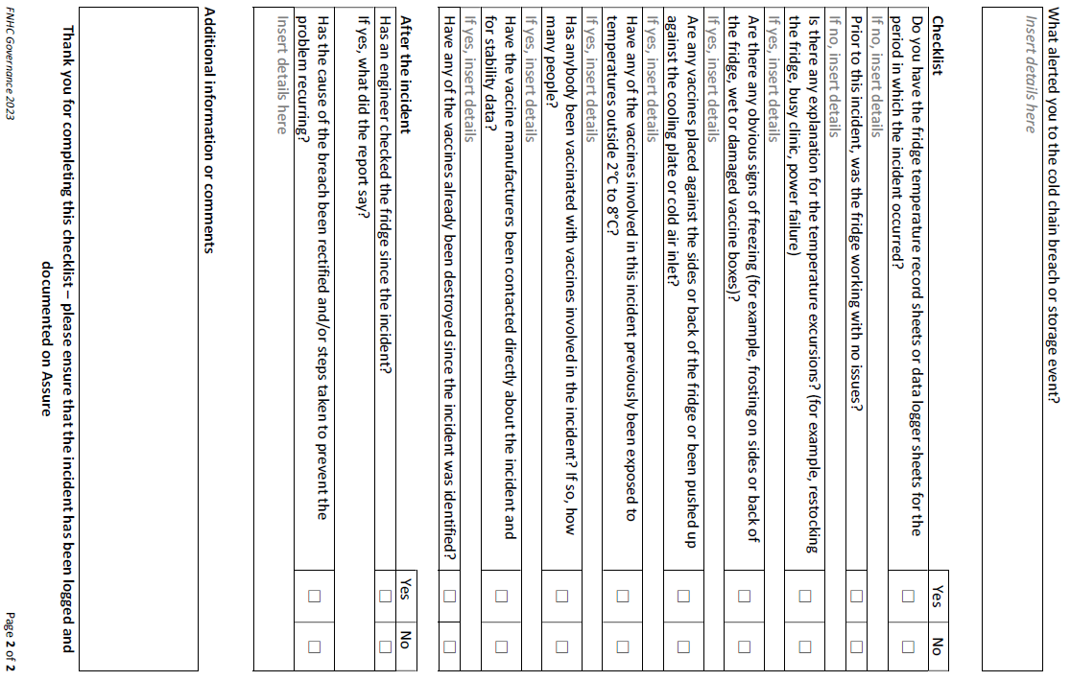

## Appendix 7 Pharmaceutical Standard Fridge Audit Tool



*Press “ctrl” and click the above to open this document*

[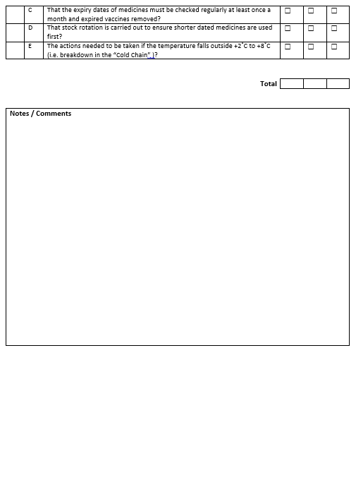](https://fnhcje.sharepoint.com/:w:/r/sites/FNHC/Shared%20Documents/General/Vaccine%20Fridge%20Documents/Yearly%20audit%20Medicines%20Fridge.docx?d=w8810940d83a7458bad93c67c9a02eb2f&csf=1&web=1&e=GOrD25)

## Appendix 9 Cleaning Log



Medicines Fridge Cleaning Log

|  |  |  |  |  |  |
| --- | --- | --- | --- | --- | --- |
| Date | Time | Interior (ü) | Exterior (ü) | Name | Signature |
|  |  |  |  |  |  |
|  |  |  |  |  |  |
|  |  |  |  |  |  |
|  |  |  |  |  |  |
|  |  |  |  |  |  |
|  |  |  |  |  |  |
|  |  |  |  |  |  |
|  |  |  |  |  |  |
|  |  |  |  |  |  |
|  |  |  |  |  |  |
|  |  |  |  |  |  |
|  |  |  |  |  |  |
|  |  |  |  |  |  |
|  |  |  |  |  |  |
|  |  |  |  |  |  |
|  |  |  |  |  |  |
|  |  |  |  |  |  |
|  |  |  |  |  |  |
|  |  |  |  |  |  |
|  |  |  |  |  |  |
|  |  |  |  |  |  |
|  |  |  |  |  |  |
|  |  |  |  |  |  |
|  |  |  |  |  |  |
|  |  |  |  |  |  |
|  |  |  |  |  |  |
|  |  |  |  |  |  |
|  |  |  |  |  |  |
|  |  |  |  |  |  |
|  |  |  |  |  |  |
|  |  |  |  |  |  |
| Notes / Comments | | | | | |